Project Name



Submitted By

Session

Project Supervisor

Department Name
School of Systems and Technology
University of Management and Technology
C-II Johar Town Lahore Pakistan

Dedication

Final Approval
Project Name

Panel of Examiners

- Head of Department ______________________
Department of Software Engineering
University of Management and Technology
Lahore

- Program Director ( Final Year Projects) ______________________
Department of Software Engineering
University of Management and Technology
Lahore

- Supervisor ______________________
Department of Software Engineering
University of Management and Technology
Lahore

- Co-Supervisor ______________________
(If any)

- Documentation Evaluator ______________________

Acknowledgment

Project Title
Objective

Undertaken by

Supervised by
Starting Date

Completion Date

Tools Used
Operating System
Documentation

Plagairism Report

Declaration Form

I have carefully examined the documentation of the Final Year Project titled “Project title”; and I endorse that this documentation complies with the standards of an undergraduate level Final Year Project report.
The document has been checked for plagiarism through Turnitin software available in UMT Library. The similarities of the document are within acceptable range.
Moreover, the accompanying CDs contain PDF of the documentation, as well as the source code and binaries with user manual and installation guide.

FYP Supervisor Name: ______________________________

Signature: __________________ Date:___________________

Abstract

Revision Chart
This chart contains a history of this document’s revisions. The entries below are provided solely for illustration purposes. Those entries should be deleted until the revision/s they refer to have actually been created.
The document itself should be stored in revision control, and a brief description of each version should be entered in the Revision Control System. A brief description can be repeated in this section. Revisions need not be described elsewhere in the document, unless they explain the document.

Version | Primary Author(s) | Description of Version | Date Completed
Draft | TBD | Initial draft created for distribution and review comments | (To be decided) TBD
Preliminary | TBD | Second draft incorporating initial review comments, distributed for final review | TBD
Final | TBD | First complete draft, which is placed under change control | TBD
Revision 1 | TBD | Revised draft, revised according to the change control process and maintained under change control | TBD
Revision 2 | TBD | Revised draft, revised according to the change control process and maintained under change control | TBD
Etc. | TBD | TBD | TBD

Table of Contents
New paragraphs formatted as Heading 1, Heading 2, and Heading 3 will be added to the table automatically. To update this table of contents in Microsoft Word, put the cursor anywhere in the table and press F9. If you want the table to be easy to maintain, do not change it manually.
Table of Contents 1
Definitions and Acronyms 4
List of Figures 5
List of Tables 7
1. Introduction 8
1.1 Problem Statement 9
1.2 Objectives 9
1.3 Scope of the Project 9
1.4 Significance of the Project 10
1.5 Artiificial Intelligence features 10
1.6 Project Deliverables 10
2. Domain Analysis 11
2.1 Customer 11
2.2 Stakeholders 11
2.3 Affected Groups with social or economic impact 12
2.4 Dependencies/ External Systems 13
2.5 Related Projects with feature comparision 14
2.5.1 Related Projects 14
2.5.2 Feature Comparison 15
2.6 Context Diagram 16
2.7 Data Flow Diagram Level 0 17
3. Requirements analysis 19
3.1 List of Actors 19
3.2 Product Backlog 19
3.2.1 Course Catalog 22
3.2.2 Account Management 23
3.2.3 Course Creation 25
3.2.4 Buying Courses 26
3.2.5 License Admin 27
3.2.6 Viewing Courses 28
3.2.7 Course Completion 29
3.2.8 Miscellaneous 29
3.2.9 Forms 30
3.2.10 Announcements 31
3.2.11 Quizzes 31
3.2.12 Non-Functional Requirements 33
3.2.13 Affiliates 33
3.2.14 Comments 34
3.2.15 Course Evaluation 34
3.2.16 Reporting 35
3.3 Figma UI/UX Designs 37
4. Project Planning and Execution using Sprints 53
4.1 Jira 53
4.2 Slack 53
4.3 Github Repository 53
4.4 Sprint 1 53
4.4.1 Sprint 1 Planning Meeting Minutes 53
4.4.2 Sprint 1 Backlog 55
4.4.3 Sprint 1 Design Class Diagram 58
4.4.4 Sprint 1 Sequence Diagram 59
4.4.5 Sprint 1 Decision Table 60
4.4.6 Sprint 1 Extended Test Cases 61
4.4.7 Sprint 1 Review Meeting 62
4.4.8 Sprint 1 Retrospective Meeting 64
5. System Architecture 66
5.1 System context Diagram 66
5.2 System Container Diagram 67
5.3 Component Diagram 68
5.4 Code Diagrams 69
5.5 ERD 70
5.6 Data Dictionary 72
6. Implementation details 73
6.1 Development Setup 73
6.2 Deployment setup 73
6.3 Algorithms 73
6.4 Constraints 73
6.4.1 Assumptions 73
6.4.2 System constraints 73
6.4.3 Restrictions 73
6.4.4 Limitations 73
7. Project Monitoring, control and traceability 74
7.1 Traceability Matrix 74
7.1.1 Requirements vs Prototype (PB-ID vs PID) 74
7.1.2 Requirements vs Test Cases (PB-ID vs TID) 75
8. Results/Output/Statistics 77
8.1 %completion 77
8.2 %accuracy 77
8.3 %correctness 77
9. Conclusion 78
10. Future work 79
11. Bibliography 80
11.1 Books 80
11.2 Journals 80
11.3 Articles 80
11.4 Research papers 80
11.5 Other References 80
12. Appendix 81
12.1 Glossary of terms 81
12.2 Pre-requisites 81

Definitions and Acronyms
Provide definitions or references to all the definitions of the special terms and acronyms used within this document

Table 1 : List of acronyms and definitions
Acronym | Definition
UMT | University of Management and Technology
CTS | Chemical Tracking System

List of Figures
New figures that are given captions will be added to the table automatically.
- Insert caption:
  - select picture
  - right click
  - select “insert caption”
  - under “options”, choose label as “figure”
  - Under “caption”, an automatic insertion of “figure no” will appear. Give your figure an appropriate caption
- Update list of figures:To update this list in Microsoft Word, put the cursor anywhere in the table and press F9.
- Note: If you want the table to be easy to maintain, do not change it manually.

Figure 1: Context Diagram - Chemical Tracking System [1] 16
Figure 2: Data Flow Diagram - Chemical Tracking System[1] 17
Figure 3: Epic vs User Story in Product Backlog [1] 19
Figure 4: Prototype - PID1- Sign Up Page UI 37
Figure 5: Prototype - PID2- Sign In Page UI 38
Figure 6: Prototype - PID3- Home Page UI Partial 39
Figure 7: Prototype - PID4- Course Listing Page 40
Figure 8: Prototype - PID5- Course Details Page 41
Figure 9: Prototype - PID6- Cart Page 42
Figure 10: Prototype - PID7- Checkout Page 43
Figure 11: Prototype - PID8- Instructor Registration Page 44
Figure 12: Prototype - PID9- Instructor Listing Page 45
Figure 13: Prototype - PID10- Instructor Detail Page 46
Figure 14: Prototype - PID11- Student Registration Page 47
Figure 15: Prototype - PID12- Pricing Page 48
Figure 16: Prototype - PID13- Event Listing Page 49
Figure 17: Prototype - PID14- Event Detail Page 50
Figure 18: Prototype - PID14- 404 Page 51
Figure 19: Prototype - PID14- FAQs Page 52
Figure 20: Class diagram of Sprint 1 features [4] 58
Figure 21: Sample Sprint 1 Sequence diagram POS 1 [2] 59
Figure 22: Sample Sprint 1 Sequence diagram POS [2] 60
Figure 23: Sample Sprint 1 Decision Table Chemical Tracking System 60
Figure 24: System context Diagram [5] 66
Figure 25: System container Diagram [5] 67
Figure 26: Component Diagram [5] 68
Figure 27: Component Diagram [5] 69
Figure 28: ER Diagram for University Scenario [3] 71
Figure 29: Data Dictionary of Chemical Tracking System [1] 72

List of Tables
New Tables that are given captions will be added to the table automatically.
- Insert caption:
  - select table
  - right click
  - select “insert caption”
  - under “options”, choose label as “table”
  - Under “caption”, an automatic insertion of “table no” will appear. Give your table an appropriate caption
- Update table: To update this table of contents in Microsoft Word, put the cursor anywhere in the table and press F9.
- Note: If you want the table to be easy to maintain, do not change it manually.

Table 1 : List of acronyms and definitions 4
Table 2: List of Stakeholders 11
Table 3: Feature comparison of our product with competitors 15
Table 4: Selected Features of Product Backlog 53
Table 5: Team Capacity Sprint 1 55
Table 6: Sprint 1 Backlog 55
Table 7: Sprint 1 Exteneded Test Case 61
Table 8: Status of Sprint 1 Backlog 62

Introduction
Background: Introduce the domain or field of the project. Explain the general area of study and how the project fits into it. Provide a brief history or evolution of related technologies or issues..
Example
Contoso Pharmaceuticals is a research-intensive company engaged in the development of new drugs. The company employs multiple chemists and pharmacists who work across various laboratories are involved in research and development of new drugs, They extensively use a wide range of chemicals for research and experimentation. However, there is no centralized system in place to track the availability and usage of chemicals across the organization. This leads to inefficient procurement practices, duplication of chemical purchases, and non-compliance risks with government safety regulations concerning sensitive substances.
Theis no track of chemical in the company. One chemical is ordered and received by one chemist or Pharmacist. Container is usually not used entirely but other people don’t know the availability of that chemical in the company. Therefore, whenever someone else needed that same chemical, they again order the same chemical. This result in his financial burden on the company. In addition to this problem, there is another issue of government health and safety department reporting. There are some sensitive dual usage chemicals, for example chemical named ephedrine is used in drugs to treat hypotension but it can also be used to make heroine, an infamous illegal narcotic. Government also need Pharmaceutical companies to submit the report of usage of sensitive chemicals in the company in order to avoid misuse of these sensitive chemicals.
There is a need to develop a Chemical tracking system. “The system should keep track of all the chemical containers that company already have in the stockroom and in laboratories. In this way, the chemists can get some chemicals from someone down the hall instead of always buying a new container. This should save us a lot of money. Also, the Health and Safety Department needs to generate government reports on chemical usage and disposal with a lot less work than it takes them today.
The company will route orders to buy chemicals from Chemists or Pharmacists to vendors (companies who supply the chemicals) for fulfillment, the vendors will send chemical containers and invoices to Contoso Pharmaceuticals, and Contoso’s purchasing department will pay the vendors. However, those processes take place outside the scope of the Chemical Tracking System, as part of the operations of the purchasing and receiving departments. It clear that this system is not directly involved in placing orders with the vendors, receiving the products, or paying the bills. This is done offline manually.
The absence of an inventory tracking mechanism often results in multiple purchases of the same chemical, even when partially used containers are already available within the premises. This practice incurs unnecessary financial costs. Additionally, due to the presence of dual-use chemicals such as ephedrine—which is used in both legitimate pharmaceutical products and illegal narcotics—there is a pressing need to comply with government reporting requirements regarding the use and disposal of such substances.
A Chemical Tracking System is essential for addressing these challenges. The proposed system will maintain a real-time record of chemical inventory in stockrooms and labs, improve internal visibility, reduce redundant purchases, and facilitate easy generation of compliance reports.

Problem Statement
Introduce the domain or field of the project.
Explain the general area of study and how the project fits into it.
Provide a brief history or evolution of related technologies or issues.
Example
Currently, there is no digital system to monitor or track chemical inventory within Contoso Pharmaceuticals. Chemists and pharmacists often unknowingly reorder chemicals that are already available in another lab or storage area. This results in inefficient use of resources and unnecessary financial expenditures. Furthermore, manual processes for regulatory reporting on sensitive chemicals are time-consuming and error-prone, exposing the company to compliance risks.

Objectives
List the main goals the project aims to achieve.
Include both primary and secondary objectives if applicable.
Example
The primary objectives of this project are:
- To develop a centralized Chemical Tracking System for recording chemical container availability across all laboratories and storage facilities.
- To enable real-time visibility of chemical inventory to all authorized personnel.
- To minimize redundant chemical purchases through better resource utilization.
- To facilitate automated report generation for government regulatory bodies regarding the usage and disposal of sensitive chemicals.

Scope of the Project
Define the boundaries of the project.
Explain what will be included and what is beyond the scope (limitations).
Example
Included in Scope:
- Development of a web-based system to record and view the status of chemical containers.
- User roles for chemists, lab managers, and administrators.
- Inventory search and request features.
- Logging of usage and disposal of sensitive chemicals.
- Report generation module for regulatory compliance.
Out of Scope:
- Integration with external vendor systems.
- Payment processing and vendor communication (done manually by the purchasing department).
- Receiving and shipping operations.

Significance of the Project
Explain the importance and expected impact of the project.
Discuss how it contributes to academia, industry, or society.
Example
This system will significantly reduce the financial burden on Contoso Pharmaceuticals by preventing duplicate chemical purchases. It will also enhance collaboration among research personnel through improved visibility into chemical availability. Most importantly, the system will streamline the regulatory reporting process, helping the company avoid penalties and meet compliance obligations related to hazardous and dual-use chemicals.

Artiificial Intelligence features
This section should describe the scenarios where AI can be used in the project.
Example
To further enhance the functionality and value of the Chemical Tracking System, Artificial Intelligence (AI) can be integrated into the system.
The following are three key AI-based scenarios that are relevant and beneficial for the proposed project:
Predictive Inventory Management: Using machine learning algorithms, the system can analyze historical usage data of chemicals to forecast future demand. This allows the company to: - Proactively manage inventory and reduce chemical waste. - Automatically suggest optimal reorder points for critical chemicals. - Prevent stockouts or overstocking of commonly used substances.
Anomaly Detection for Misuse of Sensitive Chemicals: An AI-powered anomaly detection module can monitor the usage patterns of dual-use or sensitive chemicals (e.g., ephedrine). It can: - Detect unusual activity such as excessive withdrawals or abnormal usage frequency. - Flag potential misuse or unauthorized access to restricted chemicals. - Generate real-time alerts to safety officers and compliance teams.
Automated Regulatory Report Generation: Natural Language Processing (NLP) and data extraction techniques can be used to: - Automatically generate required government compliance reports in standardized formats. - Summarize chemical usage logs in human-readable formats. - Reduce manual workload for the Health and Safety Department, ensuring timely and accurate reporting.

Project Deliverables
List the expected outputs (e.g., software application, report, hardware prototype).

Example
- A functional web-based Chemical Tracking System.
- User manual and documentation.
- Sample data and test cases.
- Government-compliance report templates.
- Final report and project presentation.

Domain Analysis

Customer
A brief description of the client with whom you are working (or the potential customers). The organization, its products/services etc.
You will fill this section only if you have a client (contracted) .
Contoso Pharmaceuticals is product customer. It is a pharmaceutical company with skills and team in new drug discovery and development. They have a highly skilled team of chemists and Pharmacist working in different labs that are involved in research and development of new drugs. They extensively use different chemicals for research and experimentation.

Stakeholders
List of all stakeholders along with their roles in making of the system e.g

Table 2: List of Stakeholders
Stakeholder | Role in System
Chemists / Pharmacists | Use chemicals for research and experimentation in laboratories.  Record the usage, quantity, and disposal of chemicals through the system.  Check inventory availability before placing new requests.  Request chemicals from the stockroom or other labs.  Ensure proper labeling and safety compliance during handling.
Buyers | Receive chemical requests from chemists and pharmacists.  Place purchase orders with external vendors (this is outside the system scope but influenced by it).  Coordinate delivery and invoice processing with vendors.  Update the system manually after receiving new chemical containers.
Chemical Stockroom Staff | Manage the physical storage and distribution of chemicals.  Update the system with details of received, available, and dispensed chemicals.  Fulfill chemical requests raised by chemists or pharmacists.  Ensure chemicals are stored according to safety regulations.
Health and Safety Department | Monitor and enforce safety standards for handling hazardous chemicals.  Verify that staff members are trained and certified to use specific hazardous or controlled substances.  Audit chemical usage logs to ensure compliance with internal and external regulations.  Generate and submit periodic reports to government authorities regarding the use, storage, and disposal of sensitive or controlled chemicals (e.g., ephedrine).
System Administrator / IT Support | Maintain user accounts, roles, and system access controls.  Ensure data integrity, backup, and security of the chemical tracking system.  Provide technical support and maintain system uptime.
Government Regulatory Authorities (External Stakeholder) | Not direct users of the system but receive reports generated by the Health and Safety Department.  Enforce compliance regulations regarding controlled substances.  Review chemical usage data for auditing and legal compliance purposes.

Affected Groups with social or economic impact
Those impacted by the deployment of the system. This can be a simple list as well as a bulleted one with short explanations.Link them with your objectives
e.g.
- Sales staff
There will be reduced paper work for them. Also they will be able to provide better customer care as system will help them respond to queries quickly.
This may include users as well as support groups

Contoso Pharmaceuticals (Organization-wide)
Economic Impact: The company will benefit from reduced waste, fewer redundant purchases, and more efficient resource utilization, leading to significant cost savings.
Social Impact: Improved operational efficiency enhances the company’s reputation as a responsible and compliant pharmaceutical company.
Research and Development (R&D) Teams
Economic Impact: Faster access to required chemicals improves productivity and shortens drug development cycles, indirectly improving revenue potential.
Social Impact: Scientists work in a safer, more accountable environment with better collaboration among labs.
Health and Safety Personnel
Economic Impact: Reduced time and effort in compliance reporting and manual inspections, allowing the department to allocate resources more effectively.
Social Impact: Improved workplace safety and lower risk of accidents, chemical exposure, or misuse of hazardous substances.
Government Regulatory Bodies
Social Impact: Improved regulatory compliance and transparency help government agencies monitor and control the usage of dual-use or hazardous chemicals, protecting public health and security.
Economic Impact: Reduced costs in enforcement and auditing due to better self-regulation by companies like Contoso.
Local Community / General Public
Social Impact: Enhanced chemical safety protocols reduce the risk of leaks, spills, or misuse, improving environmental health and community safety.
Economic Impact: Preventing fines or shutdowns due to non-compliance helps maintain local employment and economic activity.

Chemical Suppliers / Vendors
Economic Impact: Improved demand forecasting and order efficiency may reduce overstocking and streamline logistics for suppliers.
Social Impact: Strengthened business relationships with a compliant and efficient client.

Dependencies/ External Systems
Systems and/ or products, this project depends upon for its completion.
e.g.
- Cyber Cash
Enterprise Resource Planning (ERP) System
Purpose: Manages procurement, finance, inventory, and human resources.
Interaction: Purchase orders and invoices are processed here; chemical tracking data (like low inventory alerts) may influence procurement decisions.

Vendor Management Systems / Supplier Portals
Purpose: Used by the purchasing department to place chemical orders with suppliers.
Interaction: The chemical tracking system may inform purchasing decisions, but the actual order and fulfillment process takes place in external vendor systems.

Government Compliance Reporting Systems
Purpose: Platforms provided by regulatory authorities for submitting chemical usage and safety compliance reports.
Interaction: The Health and Safety Department generates reports using data from the tracking system and uploads them to government portals (e.g., for controlled substances like ephedrine).

Learning Management System (LMS) or Training Records Database
Purpose: Manages staff training and certifications.
Interaction: Health and Safety staff may need to verify whether a chemist is trained to handle hazardous chemicals by accessing records in this external system.

Inventory or Warehouse Management Systems (WMS)
Purpose: Handles the logistics of chemical storage and retrieval at scale.
Interaction: In larger operations, a WMS may handle physical stock movement while the chemical tracking system focuses on chemical-level detail and regulatory data.

Laboratory Information Management System (LIMS)
Purpose: Manages lab workflows, experiment tracking, and sample data.
Interaction: Lab staff might cross-reference chemicals used in experiments with the tracking system.

Financial/Accounting Systems
Purpose: Tracks spending, budgeting, and vendor payments.
Interaction: While not directly connected, reports from the tracking system may inform financial analysis or audits.

Related Projects with feature comparision
Provide references to all related projects that are offering similar functionalities and compare your idea with that project.

Related Projects
List of all the documents/ projects that you have looked up as reference material for this project along with their links/references. E.g

Enterprise Resource Planning (ERP) Systems
Purpose: Integrate core business processes, including procurement, finance, and inventory management.
Examples: SAP, Oracle NetSuite, Microsoft Dynamics.
Relevance: While ERPs manage overall business operations, they may lack specialized features for detailed chemical tracking and compliance.

Laboratory Information Management Systems (LIMS)
Purpose: Manage laboratory workflows, sample tracking, and data management.
Examples: LabWare, LabCollector, QBench.
Relevance: LIMS are tailored for laboratory environments, offering functionalities like sample tracking and experiment data management.

Warehouse Management Systems (WMS)
Purpose: Oversee warehouse operations, including inventory tracking and order fulfillment.
Examples: Fishbowl, NetSuite WMS, Manhattan Associates.
Relevance: WMS focus on the physical movement and storage of goods but may not provide detailed chemical compliance features.

Chemical Inventory Management Software
Purpose: Specifically designed to track chemical inventories, ensure safety compliance, and manage hazardous materials.
Examples: Chemical Safety's EMS, Quartzy, ChemInventory.
Relevance: These systems offer specialized features like Safety Data Sheet (SDS) management, regulatory reporting, and hazard classification.

Feature Comparison

Table 3: Feature comparison of our product with competitors
Feature / System | ERP Systems | LIMS | WMS | Chemical Inventory Software
Primary Focus | Business Processes | Laboratory Workflows | Warehouse Operations | Chemical Compliance & Tracking
Chemical Tracking | Limited | Moderate | Limited | Extensive
Safety Data Sheet (SDS) Management | No | Partial | No | Yes
Regulatory Compliance Reporting | Limited | Partial | No | Yes
Hazard Classification | No | Partial | No | Yes
Integration with Procurement Systems | Yes | Partial | Yes | Partial
Sample Management | No | Yes | No | No
Inventory Optimization | Yes | No | Yes | Partial
User Training Management | No | Partial | No | Partial
Cost | High | Moderate to High | Moderate | Moderate

Context Diagram
The scope [1] description establishes the boundary and connections between the system you’re developing and everything else in the universe. The context diagram visually illustrates this boundary. It identifies external entities (also called terminators) outside the system that interface to it in some way, as well as data, control, and material flows between the terminators and the system. The context diagram is the top level in a data flow diagram developed according to the principles of structured analysis.
Figure below illustrates a portion of the context diagram for the Chemical Tracking System. The entire system is depicted as a single circle; the context diagram deliberately provides no visibility into the system’s internal objects, processes, or data. The “system” inside the circle could encompass any combination of software, hardware, and human components. Therefore, it could include manual operations as part of the entire system. The external entities in the rectangles can represent user classes (Chemist, Buyer), organizations (Health and Safety Department), other systems (Training Database), or hardware devices (Bar Code Reader). The arrows on the diagram represent the flow of data (such as a request for a chemical) or physical items (such as a chemical container) between the system and its external entities.¹

Figure 1: Context Diagram - Chemical Tracking System [1]

Data Flow Diagram Level 0
Identifies actual data flows and data stores
DFDs [1] provide a big-picture view of how data moves through a system, which other models don’t show well. Various people and systems execute processes that use, manipulate, and produce data. Other diagram can’t show you the full life cycle of a piece of data. Multiple pieces of data might be pulled together and transformed by a process (for example, shopping cart contents plus shipping information plus billing information are transformed into an order object).
You are explaining the context diagram into a level 0 DFD which partitions the system into its major processes. Following Figure shows a partial level 0 DFD for the Chemical Tracking System.¹
Figure 2: Data Flow Diagram - Chemical Tracking System[1]

The single circle that represented the entire Chemical Tracking System on the context diagram has been subdivided into six major processes (the process bubbles). As with the context diagram, the external entities are shown in rectangles. All data flows (arrows) from the context diagram also appear on the level 0 DFD. In addition, the level 0 diagram contains several data stores, depicted as a pair of parallel horizontal lines, which are internal to the system and therefore do not appear on the context diagram. A flow from a bubble to a store indicates that data is being placed into the store, a flow out of the store shows a read operation, and a bidirectional arrow between a store and a bubble indicates an update operation.
Each process that appears as a separate bubble on the level 0 diagram can be further expanded into a separate DFD to reveal more detail about its functioning

Requirements analysis

List of Actors
We are giving a sample list of Actors of online Learning platforms such as udemy or coursera.or our own developed by UMT named https://livex.tech/
Define the system boundary and list all actors with the user stories.of all the actors must also be mentioned in your list of stakeholders
For example:
Instructor; who creates a course one an online learning platform
Participant; this person who registers in a course and attempt, quizzes, assignments and exam and earn a certificate.
Site Visitor; this person who is interested in online learning platform.
Company User; this person who represents a company. On company license multiple employees of the company can use on online learning platform.
Search Engine: Search Engine bots need to view a site map so that all pages are indexed.
Partner Company: They provide links to our web site and get paid for referring people to the site.

Product Backlog
We are giving a sample Product backlog of online Learning platforms such as udemy or coursera or our own developed by UMT named https://livex.tech/
Online learning platforms are digital spaces where people can learn new skills, gain knowledge, and advance their education, all from the comfort of their own homes. Think of them as virtual schools or universities, but with a lot more flexibility and accessibility.
Following are important concepts related to Product backlog:

Figure 3: Epic vs User Story in Product Backlog [1]

Sprint:
In Agile project management, a sprint is a fixed-length period during which a team works to complete a set of tasks and deliver a potentially shippable increment of product. Sprints are typically one to four weeks long, but two to three weeks is a common duration.
Epic:
An epic is a user story that is too large to fully implement in a single iteration. Its a multi-sprint project goal or a broad area of functionality that requires significant development effort. Because epics span iterations, they must be split into sets of smaller stories. Sometimes epics are large enough that they must be subdivided into multiple epics, each of which is then split into multiple stories until each resulting story can be reliably estimated and then implemented and tested within a single iteration. Breaking epics down into smaller epics and then into user stories is often referred to as story decomposition
Scope:
Covers multiple releases or iterations and often spans across several teams.
Purpose:
Provides a high-level overview of the project and helps in prioritizing and planning the release.
Example:
"Implement e-commerce functionality".
Feature:
A specific piece of functionality or a deliverable within an Epic that provides value to the user.
Scope:
Smaller than an Epic and can be developed and released in a single iteration.
Purpose:
Breaks down the Epic into manageable chunks and guides the development process.
Example:
"Product listing page," "Order page," "Payment page" within the "e-commerce functionality" Epic.
User Story:
A user story is a “short, simple description of a feature told from the perspective of the person who desires the new capability, usually a user or customer of the system”. User stories are sized so as to be fully implementable in a single iteration. Each completed user story iteratively builds the feature. User stories often are written according to the following template, although other styles also are used:
As a <type of user>, I want <some goal> so that <some reason OR Benefit>.
Scope:
The smallest unit of work that can be delivered within a sprint.
Purpose:
Captures the requirements of a feature in a way that is easy for developers to understand and implement.
Example:
"As a user, I want to add items to my shopping cart so that I can buy them later"

Acceptance Criteria
A set of conditions or rules that a user story must satisfy to be considered "done" and accepted by the product owner.
Purpose:
To define what success looks like for a user story.
Written by:
Usually written by the product owner, sometimes with input from QA and developers.
Format:
Often in plain language or BDD style (Given-When-Then).
Example:
User Story: As a user, I want to reset my password so I can access my account if I forget it.
Acceptance Criteria:
The user must be able to request a password reset by entering their email.
The system must send a reset link if the email is registered.
The reset link must expire in 24 hours.
The user must be able to set a new password via the reset link.

Story Point:
In Agile, story points are a relative unit of measurement used to estimate the effort required to complete a user story or other piece of work. They are not time-based but rather represent the complexity and effort relative to other items on the backlog.
Key aspects of story points range in Agile:
Relative, not absolute:
Story points are assigned relative to other tasks, meaning a story with 2 points is roughly twice as complex as a story with 1 point.
No specific time value:
Story points don't directly equate to hours or days; they represent a degree of effort or complexity.
Common scales:
Teams often use scales like Fibonacci (1, 2, 3, 5, 8, 13...)
Benefits:
Story points help teams estimate work, plan sprints, and manage expectations, rather than focusing on individual time estimates.

Backlog grooming:
It is a process where the product owner and development team collaboratively review and refine the product backlog. It is a crucial practice in Agile project management that involves regularly updating and refining the product backlog. It focuses on ensuring the backlog is well-defined, prioritized, and ready for upcoming sprint cycles, ultimately contributing to a more efficient and effective development process.
This includes activities like:
Refining user stories: Making sure they are clear, concise, and easy to understand.
Breaking down large items: Dividing complex tasks into smaller, more manageable units.
Estimating effort: Assessing how much work each item will require.
Prioritizing items: Determining which tasks should be tackled first.
Adding new items: Incorporating newly discovered requirements or features.
Removing outdated items: Eliminating items that are no longer relevant.
Why it's important:
Improves sprint planning:
A well-groomed backlog allows the team to effectively plan and execute sprints.
Enhances collaboration:
The process promotes communication and collaboration between the product owner and development team.
Increases predictability:
By refining the backlog, the team can better predict the scope and effort required for upcoming sprints.
Keeps the backlog up-to-date:
Ensures the backlog reflects the latest needs and priorities of the product.
Benefits:
Increased velocity:
By optimizing the backlog, the team can work more efficiently and deliver more value.
Reduced risk:
A well-defined backlog helps to minimize the risk of scope creep and delays.
Improved team morale:
When the team understands what they are working on and why, they are more motivated and engaged

Sub headings in this section are epics and each epic contain multiple user stories.

Course Catalog
PB-ID | User Story | Priority | Acceptance Criteria | Story Points | Status
CC-01 | As an instructor, I can create a description of a course so that prospective participants can learn about it. | High | - Instructor can add/edit a course description.  - Course description is saved and displayed correctly. | 3 | Pending
CC-02 | As an instructor, I can maintain a bio about myself so that it is used on any course listing for which I’m the instructor. | Medium | - Instructor can add/update bio.  - Bio appears on all relevant course pages. | 2 | Pending
CC-03 | As a site visitor, I can view a detailed page about each course so that I can learn all about it. | High | - Course page displays course title, description, instructor bio, and related courses.  - Videos and syllabus are visible. | 3 | Pending
CC-04 | As a site visitor, I can browse a catalog of all courses available so that I can pick the right one for me. | High | - Course catalog lists all available courses.  - Filter and search functionality work correctly. | 5 | Pending
CC-05 | As a site visitor, I can see a list of other related courses when viewing a course so that I can see other courses I might be interested in. | Medium | - Related courses are displayed based on category, instructor, or tags. | 3 | Pending

Account Management
ID | User Story | Priority | Acceptance Criteria | Story Points | Status
AM-01 | As an instructor, I can create a description of a course so that prospective participants can learn about it. | High | - Instructor can add/edit a course description.  - Course description is saved and displayed correctly. | 3 | Pending
AM-02 | As an instructor, I can sign, login and maintain a bio about myself so that it is used on any course listing for which I’m the instructor. | Medium | - Instructor can add/update bio.  - Bio appears on all relevant course pages. | 2 | Pending
AM-03 | As a site visitor, I can view a detailed page about each course so that I can learn all about it. | High | - Course page displays course title, description, instructor bio, and related courses.  - Videos and syllabus are visible. | 3 | Pending
AM-04 | As a site visitor, I can browse a catalog of all courses available so that I can pick the right one for me. | High | - Course catalog lists all available courses.  - Filter and search functionality work correctly. | 5 | Pending
AM-05 | As a site visitor, I can see a list of other related courses when viewing a course so that I can see other courses I might be interested in. | Medium | - Related courses are displayed based on category, instructor, or tags. | 3 | Pending
AM-06 | As a student, I can Sign up, login into the system and see my registered courses (if any). | Medium | Courses are displayed | 3 | Pending

Course Creation
ID | User Story | Priority | Acceptance Criteria | Story Points | Status
CC-06 | As an instructor, I can upload videos to be part of a course so that participants can watch those videos. | High | - Instructor can upload and organize videos.  - Videos play correctly on all devices. | 5 | Pending
CC-07 | As an instructor, I can create a quiz to include in a video course so that participants can take those quizzes to ensure they are learning. | Medium | - Instructor can add questions and answers.  - Participants can submit answers and get immediate feedback. | 3 | Pending
CC-08 | As an instructor, I can properly sequence the elements of a course so that I can assemble them into an amazing course. | Medium | - Instructor can arrange content in preferred order.  - Course displays in the correct sequence. | 3 | Pending
CC-09 | As an instructor, I can set the publication date for course elements so that items become available when I want and not sooner. | Medium | - Instructor can specify release dates.  - Content becomes accessible only on the specified date. | 3 | Pending

Buying Courses
ID | User Story | Priority | Acceptance Criteria | Story Points | Status
BC-01 | As a trainer, I can set the prices for my course so that I can make filthy lucre. | High | - Trainer can define course prices.  - Prices are correctly displayed on course pages. | 3 | Pending
BC-02 | As a site visitor, I can pay for the courses in my cart with a credit card so that I can purchase them and participate in (watch) them. | High | - Secure credit card payment processing.  - User receives purchase confirmation and access. | 8 | Pending
BC-03 | As a site visitor, I can pay for the courses in my cart with PayPal so that I can purchase them and participate in (watch) them. | Medium | - PayPal integration is functional.  - Payment confirmation grants course access. | 5 | Pending
BC-07 | As a user, I can view the license terms before purchasing or subscribing so that I know what I’m getting. | High | - License terms are displayed before purchase.  - Users must accept terms before completing purchase. | 3 | Pending
BC-08 | As a participant, I can sign up for a monthly or annual subscription so that I can take all courses. | High | - Subscription plans are available.  - Users can upgrade, downgrade, or cancel subscriptions. | 5 | Pending
BC-09 | As a company, I can purchase multiple licenses so that I can manage course registrations for a group of people. | High | - Companies can buy bulk licenses.  - Admins can assign licenses to employees. | 5 | Pending
BC-10 | As a company, I manage a set of course registrations so that I can control which employees in my company have access to which courses. | High | - Company admin can manage access rights.  - Employees receive course invitations. | 5 | Pending

License Admin
ID | User Story | Priority | Acceptance Criteria | Story Points | Status
LA-01 | As a buyer, I can easily apply a license I buy to myself so that I can instantly start viewing a course. | High | - Buyer applies license automatically.  - Access is granted immediately. | 3 | Pending
LA-02 | As a buyer, I can distribute out licenses to others in my company so that they can view a course I pay for. | Medium | - Buyer can assign licenses.  - License status updates correctly. | 4 | Pending
LA-03 | As a buyer, I can share a company-wide license with everyone in my company so that everyone in the company can view the course. | Medium | - Company-wide licenses grant access to all employees.  - License admin dashboard available. | 5 | Pending

Viewing Courses
ID | User Story | Priority | Acceptance Criteria | Story Points | Status
VC-01 | As a participant, I want each course element marked as viewed after I view or complete it so that I can see which parts of a course I’ve completed. | High | - System marks viewed content.  - Users can track progress. | 3 | Pending
VC-02 | As a participant, I can re-watch any video so that I can make sure I understand it. | Medium | - Users can replay videos.  - No playback restrictions. | 2 | Pending
VC-03 | As a site visitor, I can view some videos for free so that I can decide if I want to buy the full course. | Medium | - Free preview videos are available.  - Users can play previews without logging in. | 3 | Pending
VC-04 | As a participant, I can set a mode on the videos so that one begins as the previous one finishes so that I can watch without having to touch my keyboard, mouse or screen. | Medium | - Auto-play feature is available.  - Users can enable/disable auto-play. | 3 | Pending

Course Completion
ID | User Story | Priority | Acceptance Criteria | Story Points | Status
CP-01 | As a participant, I can earn a certificate of completion by finishing a course so that I have proof that I completed a course. | High | - Certificates are auto-generated.  - Users can download or share certificates. | 5 | Pending
CP-02 | As a participant, I can earn a badge showing that I completed a course so that I can display that badge on my own website. | Medium | - Badge is displayed upon completion.  - Users can embed the badge externally. | 3 | Pending

Miscellaneous
ID | User Story | Priority | Acceptance Criteria | Story Points | Status
MS-01 | As a site visitor, I can read an FAQ so that all my questions are answered. | Low | - FAQ page is accessible.  - Common questions and answers are listed. | 2 | Pending
MS-02 | As a search engine, I can view a site map so that all pages are indexed. | Low | - Site map is dynamically generated.  - Search engines can crawl the site. | 2 | Pending
MS-03 | As a site visitor, I can sign up for a newsletter so that I get announcements about new courses and other information. | Medium | - Users can subscribe/unsubscribe.  - Emails are sent on schedule. | 3 | Pending
MS-07 | As a participant, I want the site to save my progress in a quiz or video in case I lose connection so that I don’t have to start over. | High | - Progress is saved every few minutes.  - Users can resume quizzes or videos from where they left off. | 4 | Pending
MS-08 | As a site visitor, I can access a help center with guides and FAQs so that I can quickly resolve common issues. | Medium | - Help center includes guides, FAQs, and contact support.  - Users can search for help topics. | 3 | Pending

Forms
ID | User Story | Priority | Acceptance Criteria | Story Points | Status
FO-01 | As a participant, I can participate in a forum for a course so that I can discuss questions and topics with the instructor and other participants. | Medium | - Forums are enabled per course.  - Participants and instructors can post and reply. | 4 | Pending

Announcements
ID | User Story | Priority | Acceptance Criteria | Story Points | Status
AN-01 | As an instructor, I can post announcements to a project 'home page' for a Scheduled Course so that I can tell participants about important things such as 'I’m delayed in posting chapter 7.' | Medium | - Instructors can create and edit announcements.  - Announcements are displayed to participants. | 3 | Pending
AN-02 | As a participant, I can read announcements from an instructor for a Scheduled Course so that I can keep up to date on news. | Medium | - Participants can view announcements.  - Announcements are clearly visible on the course home page. | 2 | Pending

Quizzes
ID | User Story | Priority | Acceptance Criteria | Story Points | Status
QZ-01 | As an instructor, I can create quizzes so that participants can assess their learning. | High | - Instructor can add/edit quizzes.  - Participants can take quizzes and get scores. | 5 | Pending
QZ-02 | As a participant, I can take a quiz as part of a course so that I can get feedback on how well I learned material in the previous video(s). | High | - Quiz submission and auto-scoring work.  - Feedback is displayed upon completion. | 5 | Pending
QZ-05 | As a participant, I can navigate a quiz by submitting an answer or by pressing skip (forward) or back so that I can answer questions in a different order if I’d like. | Medium | - Users can navigate back and forth in quizzes.  - Answer progress is saved. | 3 | Pending
QZ-06 | As a participant, I can get answers via video rather than text so that I watch rather than read an answer. | Medium | - Video explanations are available for quiz answers.  - Users can choose between text or video explanations. | 4 | Pending
QZ-07 | As a participant, I want quiz responses stored in the database so that I can see how people are doing at various questions, perhaps so I can fix one that is worded poorly. | Medium | - Quiz responses are stored and retrievable.  - Instructors can analyze response trends. | 3 | Pending
QZ-08 | As a participant, I can navigate a quiz by submitting an answer or by pressing skip (forward) or back so that I can answer questions in a different order if I’d like. | Medium | - Users can skip or go back to previous questions.  - Answered questions remain saved. | 3 | Pending

Non-Functional Requirements
ID | User Story | Priority | Acceptance Criteria | Story Points | Status
NFR-01 | As a visitor, I want to be able to view the site and videos in any reasonable browser so that I can use what I’m accustomed to. | High | - The site is compatible with major browsers.  - Videos play correctly across devices. | 5 | Pending

Affiliates
ID | User Story | Priority | Acceptance Criteria | Story Points | Status
AF-01 | As a partner company, I would like to provide links to https://livex.tech and get paid for referring people to the site so that I can become part of the 1%. | Medium | - Affiliate tracking system is functional.  - Payments are correctly processed. | 3 | Pending
AF-02 | As a partner company, I can embed https://livex.tech/ (free ones only) on my site so that people can enjoy those videos on my site, , possibly giving me affiliate revenue but possibly just being about putting good content on my site. | Medium | - Embedded video support for affiliates.  - Free content is available for sharing. | 3 | Pending

Comments
ID | User Story | Priority | Acceptance Criteria | Story Points | Status
CM-01 | As a participant, I can leave a comment about a course so that I can tell the world what I think of it. | Medium | - Participants can post comments.  - Comments are moderated and displayed correctly. | 3 | Pending
CM-02 | As an instructor, I can leave a comment about a sample video or the course so that I can respond to other comments. | Medium | - Instructors can reply to comments.  - Comments are visible and properly threaded. | 3 | Pending

Course Evaluation
ID | User Story | Priority | Acceptance Criteria | Story Points | Status
CE-01 | As a participant, I am shown an evaluation form after completing a course so that I can tell https://livex.tech/ what I think of their classes and their trainers. | Medium | - Evaluation form appears after course completion.  - Users can submit feedback and ratings. | 3 | Pending
CE-02 | As an instructor, I can view all feedback for a course when logged in so that I can see historical or aggregate data on my courses. | Medium | - Instructors can access feedback reports.  - Data is aggregated for trend analysis. | 3 | Pending
CE-03 | As an instructor, I can opt into receiving an email of every course evaluation as it is completed by a participant so that I get real-time feedback on my courses. | Medium | - Instructors receive email notifications of evaluations.  - Emails contain full evaluation details. | 3 | Pending
CE-04 | As an instructor, I can export all feedback for a course to a CSV file so that I can perform more in-depth analysis. | Medium | - Feedback export feature is available.  - CSV file contains all evaluation data. | 3 | Pending

Reporting
ID | User Story | Priority | Acceptance Criteria | Story Points | Status
RP-01 | As a site owner, I receive a periodic email summarizing registrations for the day, week, and month to date so that I know how we’re doing. | Medium | - Summary email includes registration statistics.  - Admin can configure email frequency. | 3 | Pending
RP-02 | As a trainer, I receive a periodic sales summary at the frequencies I select so that I know how my courses are doing. | Medium | - Trainers receive periodic reports.  - Report frequency is configurable. | 3 | Pending
RP-06 | As a trainer, I can generate reports on participant progress so that I can monitor their learning outcomes. | Medium | - Reports include participant scores and completion status.  - Trainers can filter reports by date or course. | 4 | Pending
RP-03 | As a sys admin, I can run any report a trainer can run so that I can see overall information for any trainer on the site. | Medium | - Sys admins have report access.  - Data is exportable and properly formatted. | 3 | Pending

Figma UI/UX Designs
Initial mockup screens will be inserted here. Each screen will be given an appropriate prototype id.e.g.
Link of Figma Designs:
The original Figma designs can be see at the following link. You need to share your Figma link as well like this one.
https://www.figma.com/community/file/1404410418143924515/coursehub-university-online-courses-school-education-figma-template
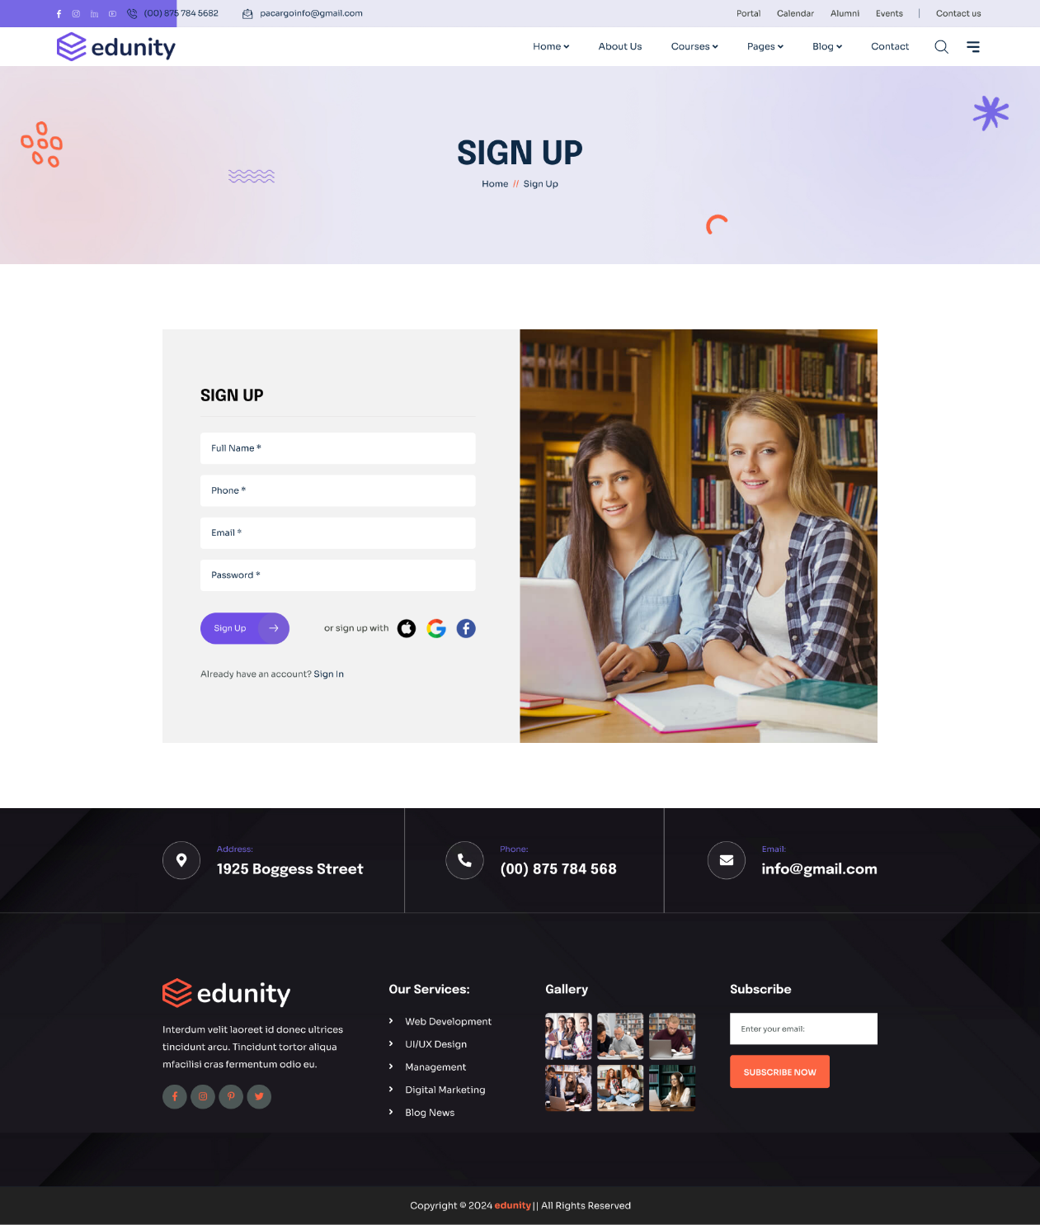
Figure 4: Prototype - PID1- Sign Up Page UI
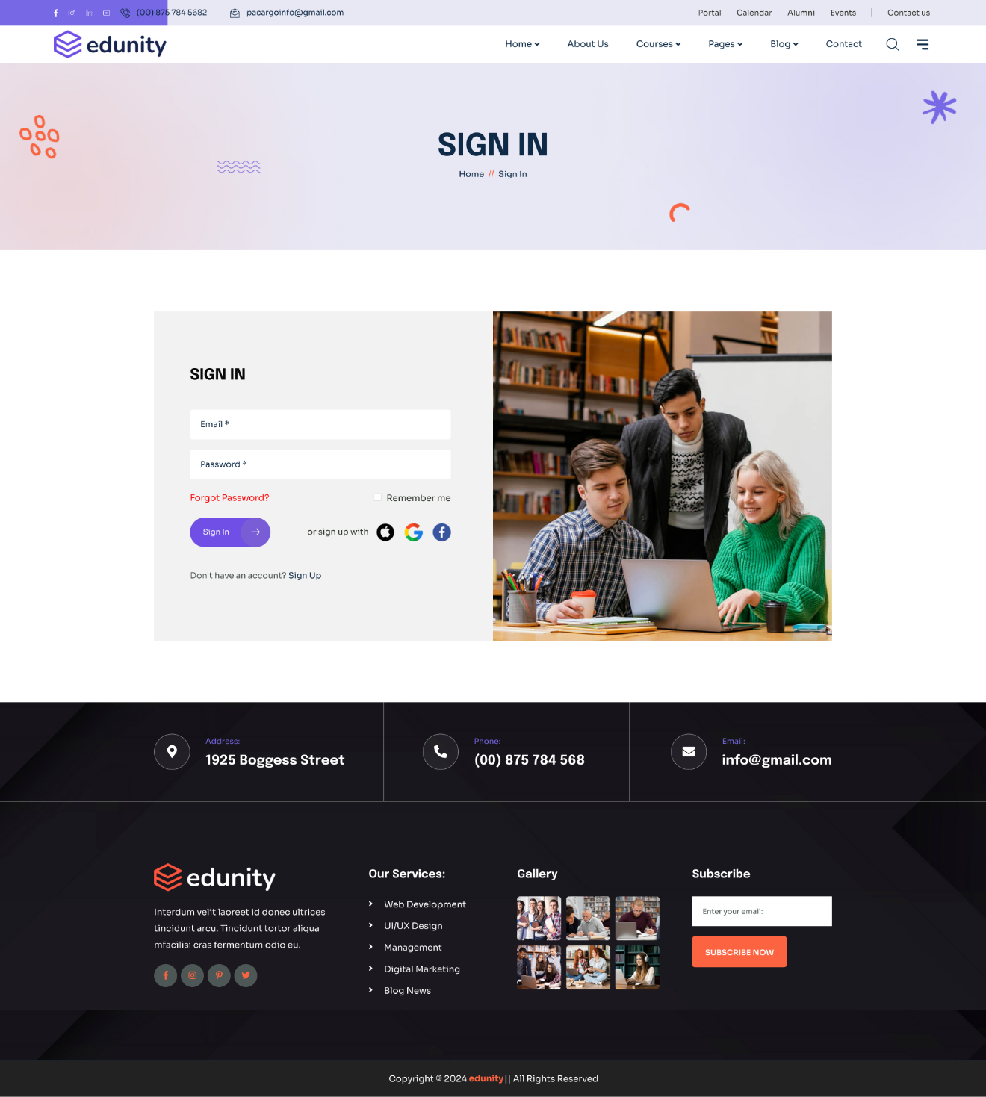
Figure 5: Prototype - PID2- Sign In Page UI

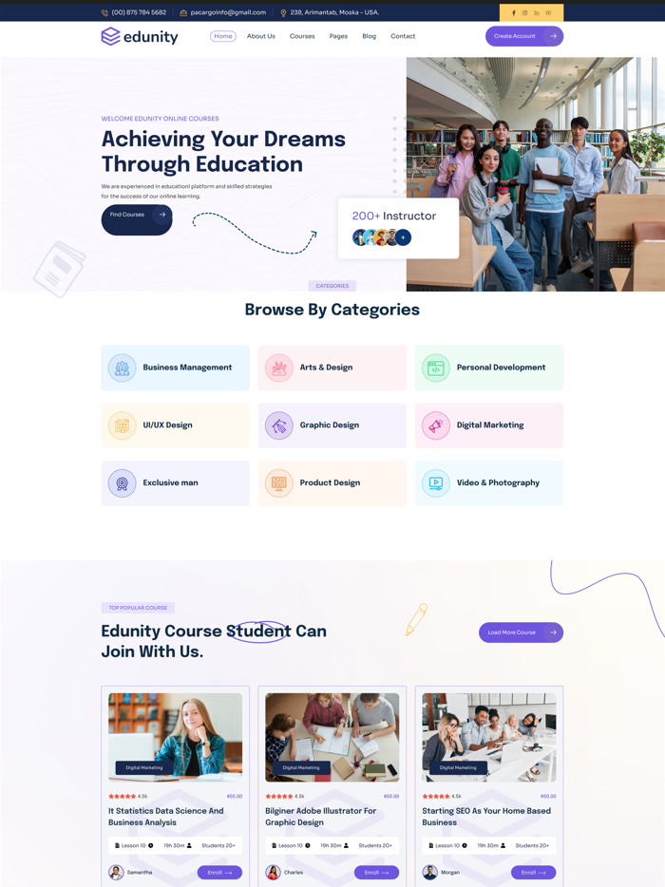
Figure 6: Prototype - PID3- Home Page UI Partial


Figure 7: Prototype - PID4- Course Listing Page


Figure 8: Prototype - PID5- Course Details Page
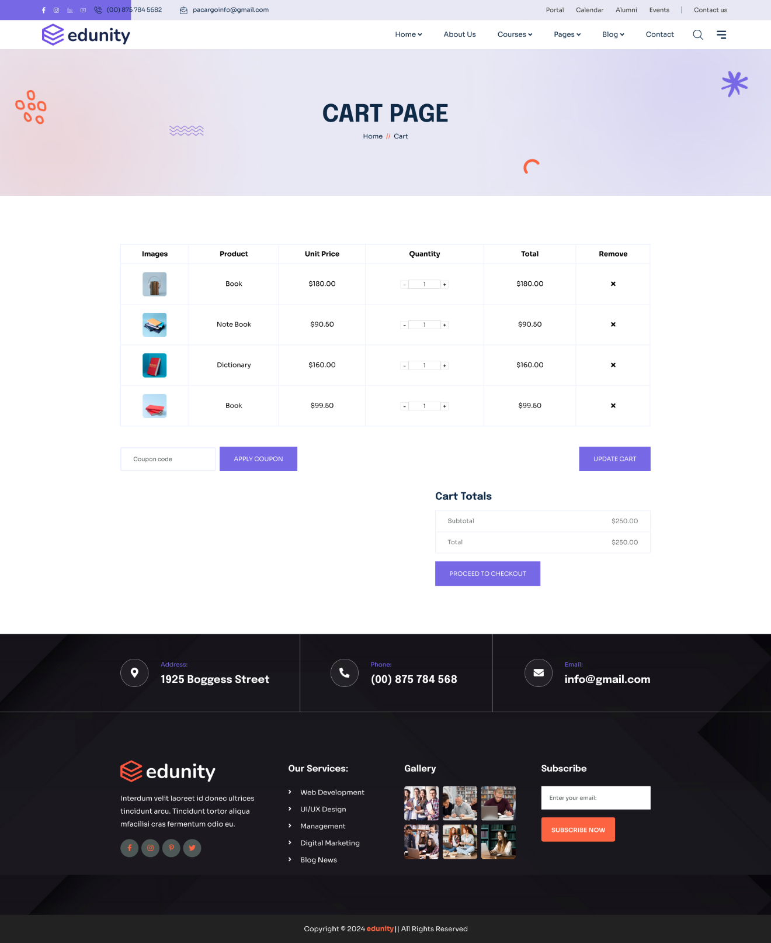
Figure 9: Prototype - PID6- Cart Page

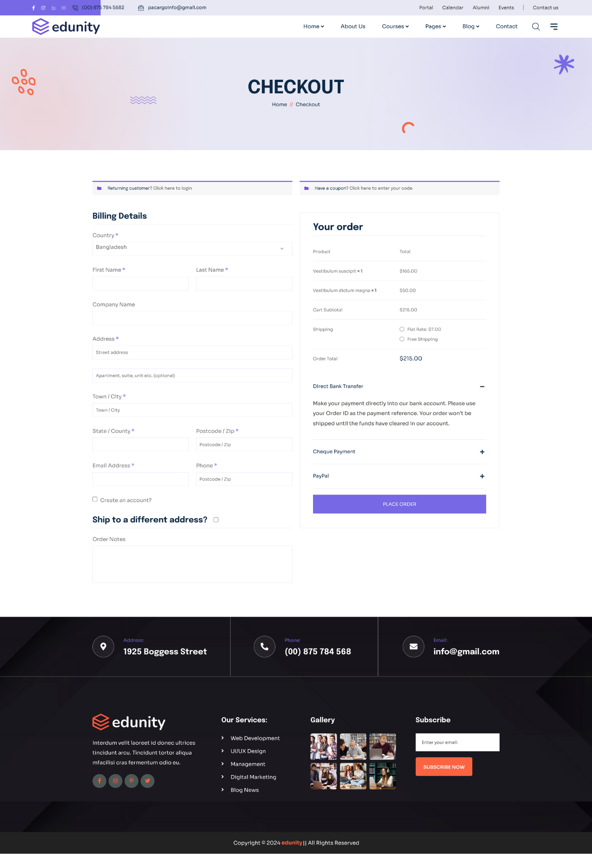
Figure 10: Prototype - PID7- Checkout Page
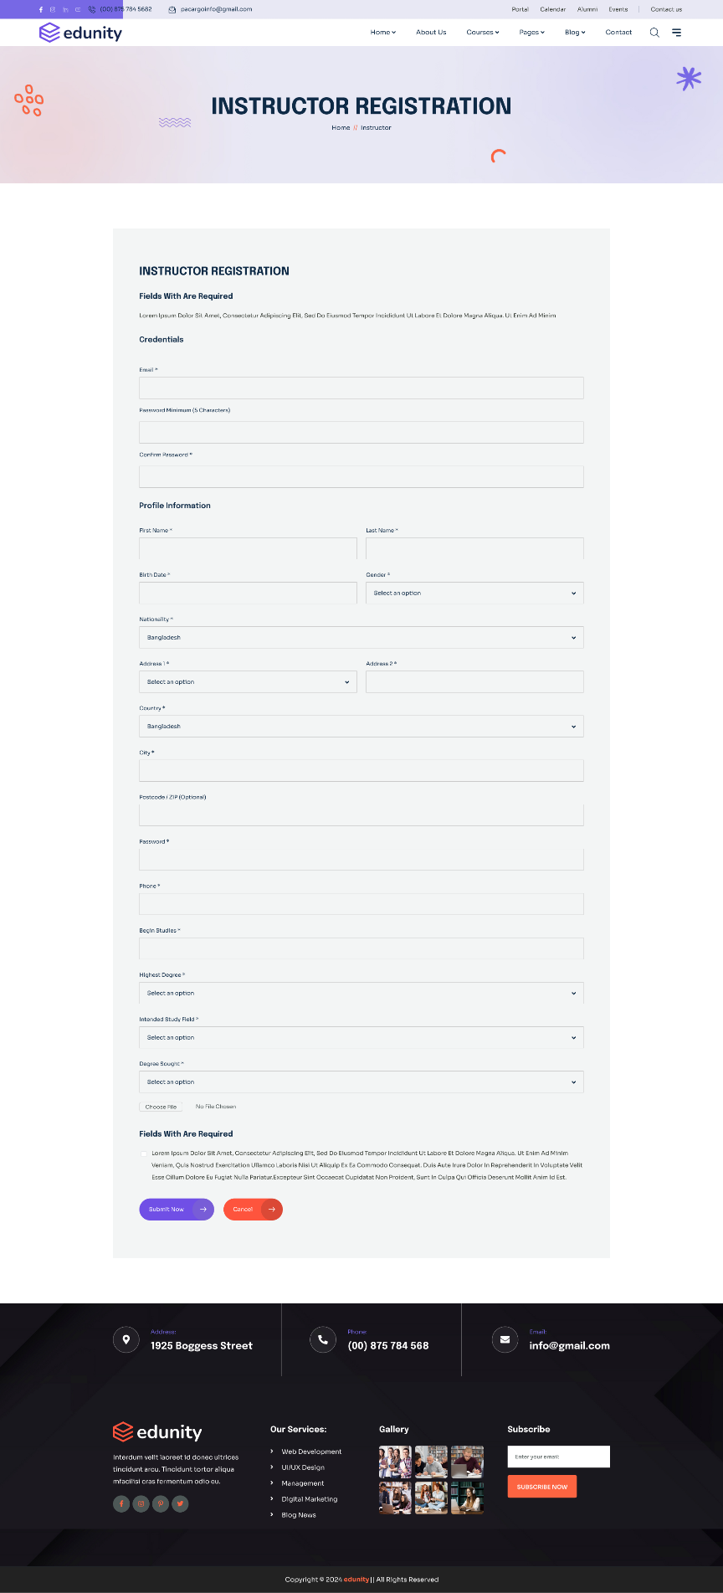
Figure 11: Prototype - PID8- Instructor Registration Page

Figure 12: Prototype - PID9- Instructor Listing Page

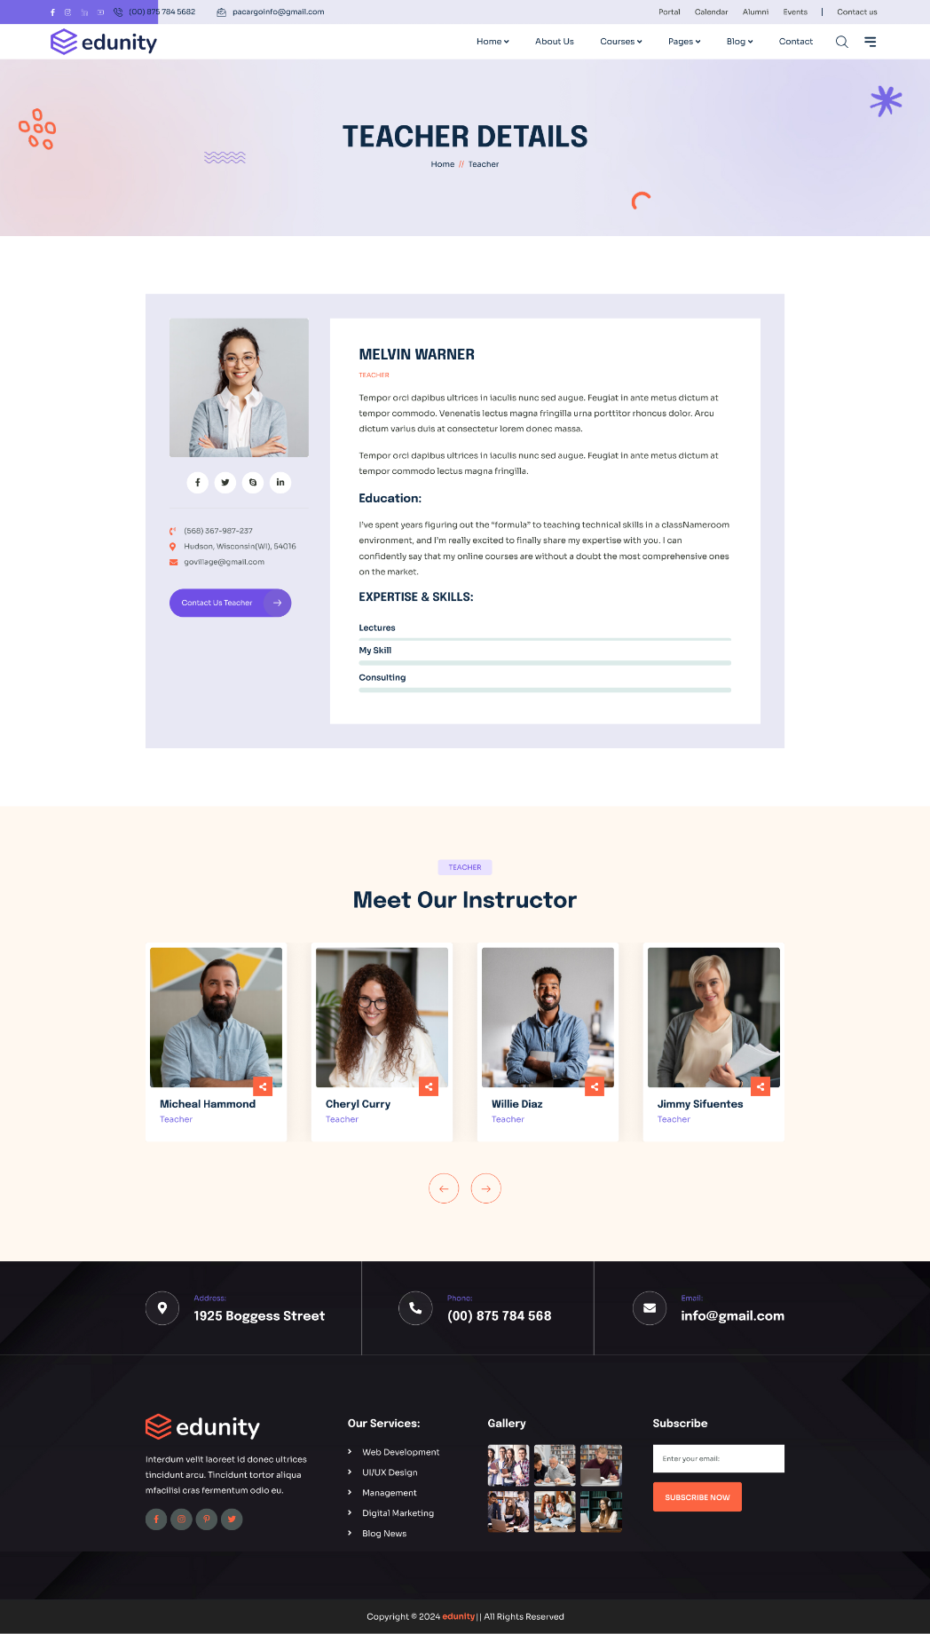
Figure 13: Prototype - PID10- Instructor Detail Page
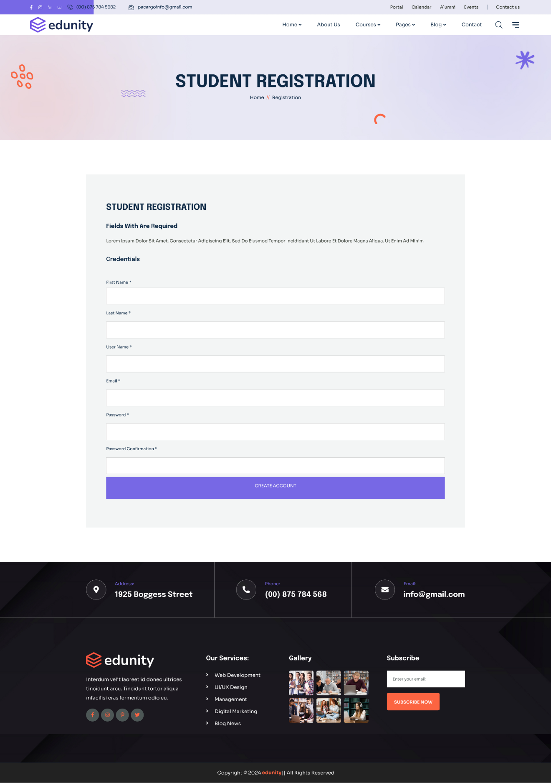
Figure 14: Prototype - PID11- Student Registration Page

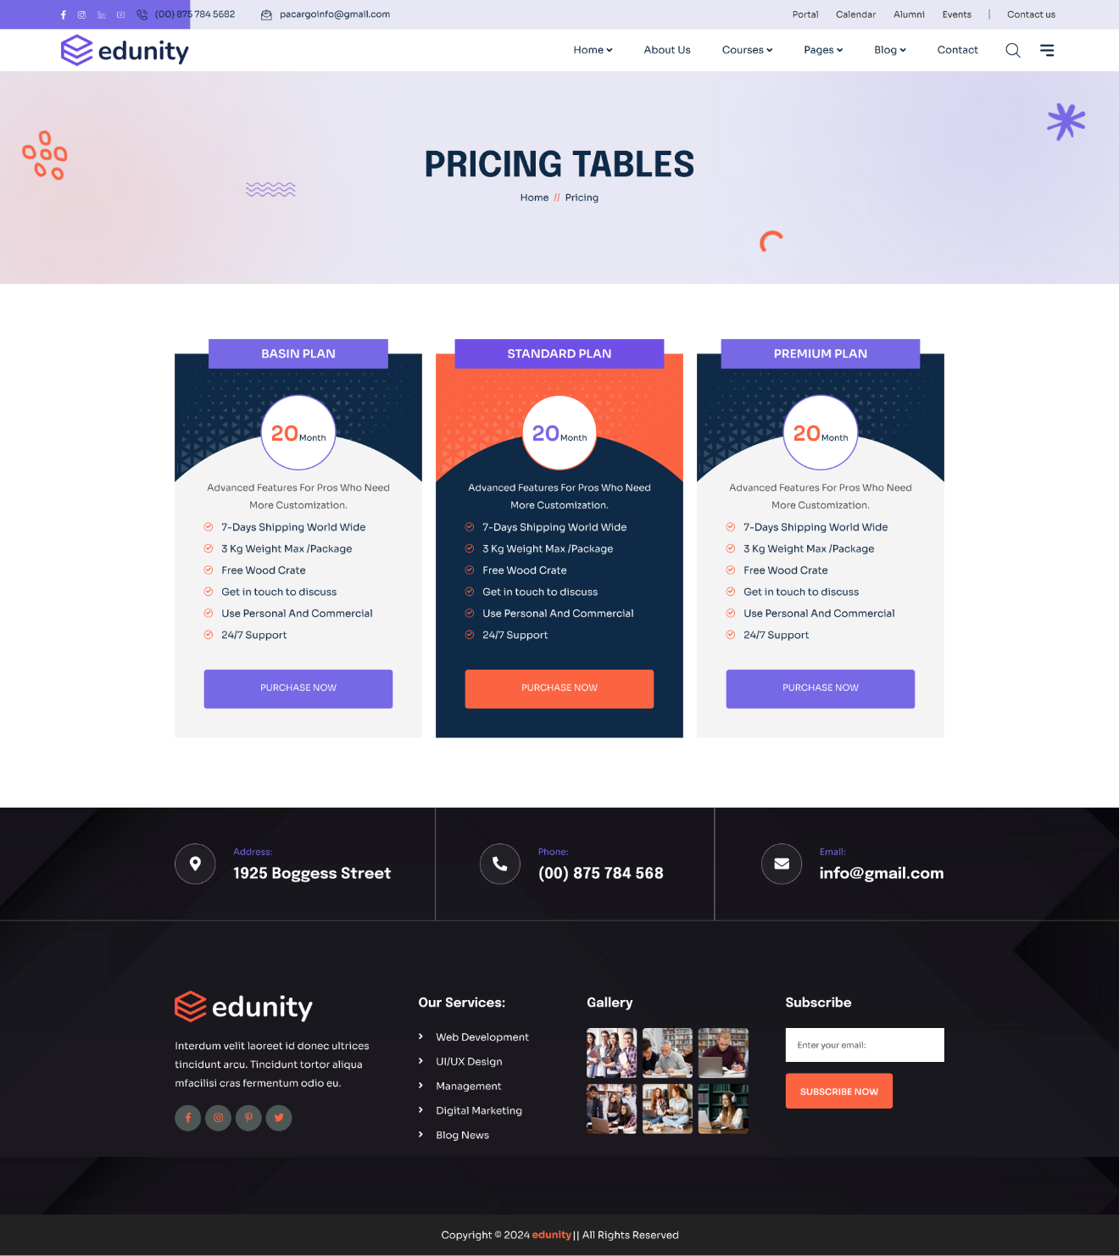
Figure 15: Prototype - PID12- Pricing Page

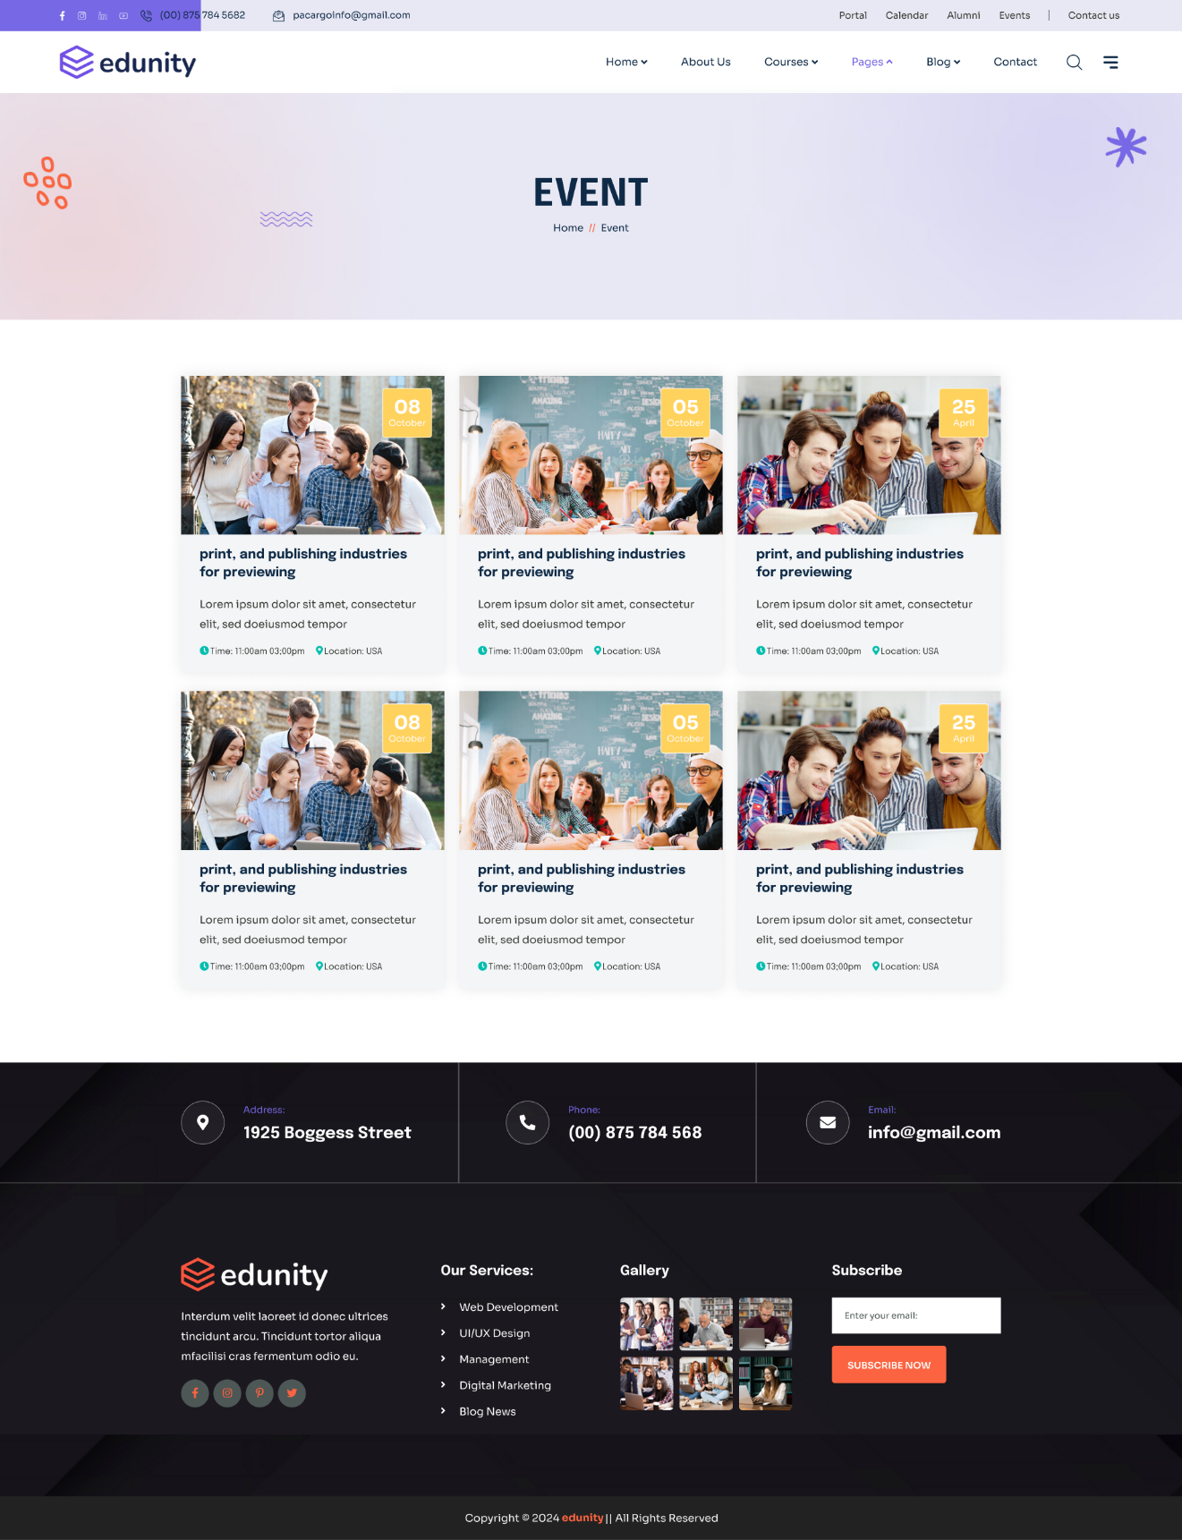
Figure 16: Prototype - PID13- Event Listing Page


Figure 17: Prototype - PID14- Event Detail Page

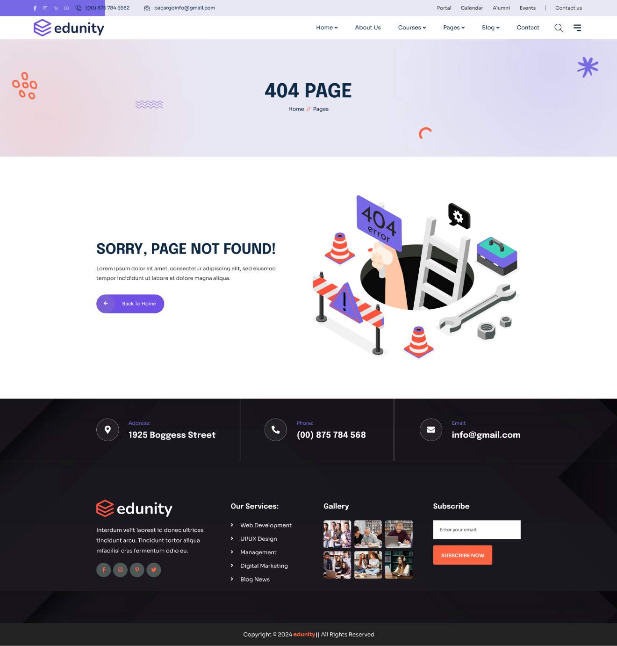
Figure 18: Prototype - PID14- 404 Page

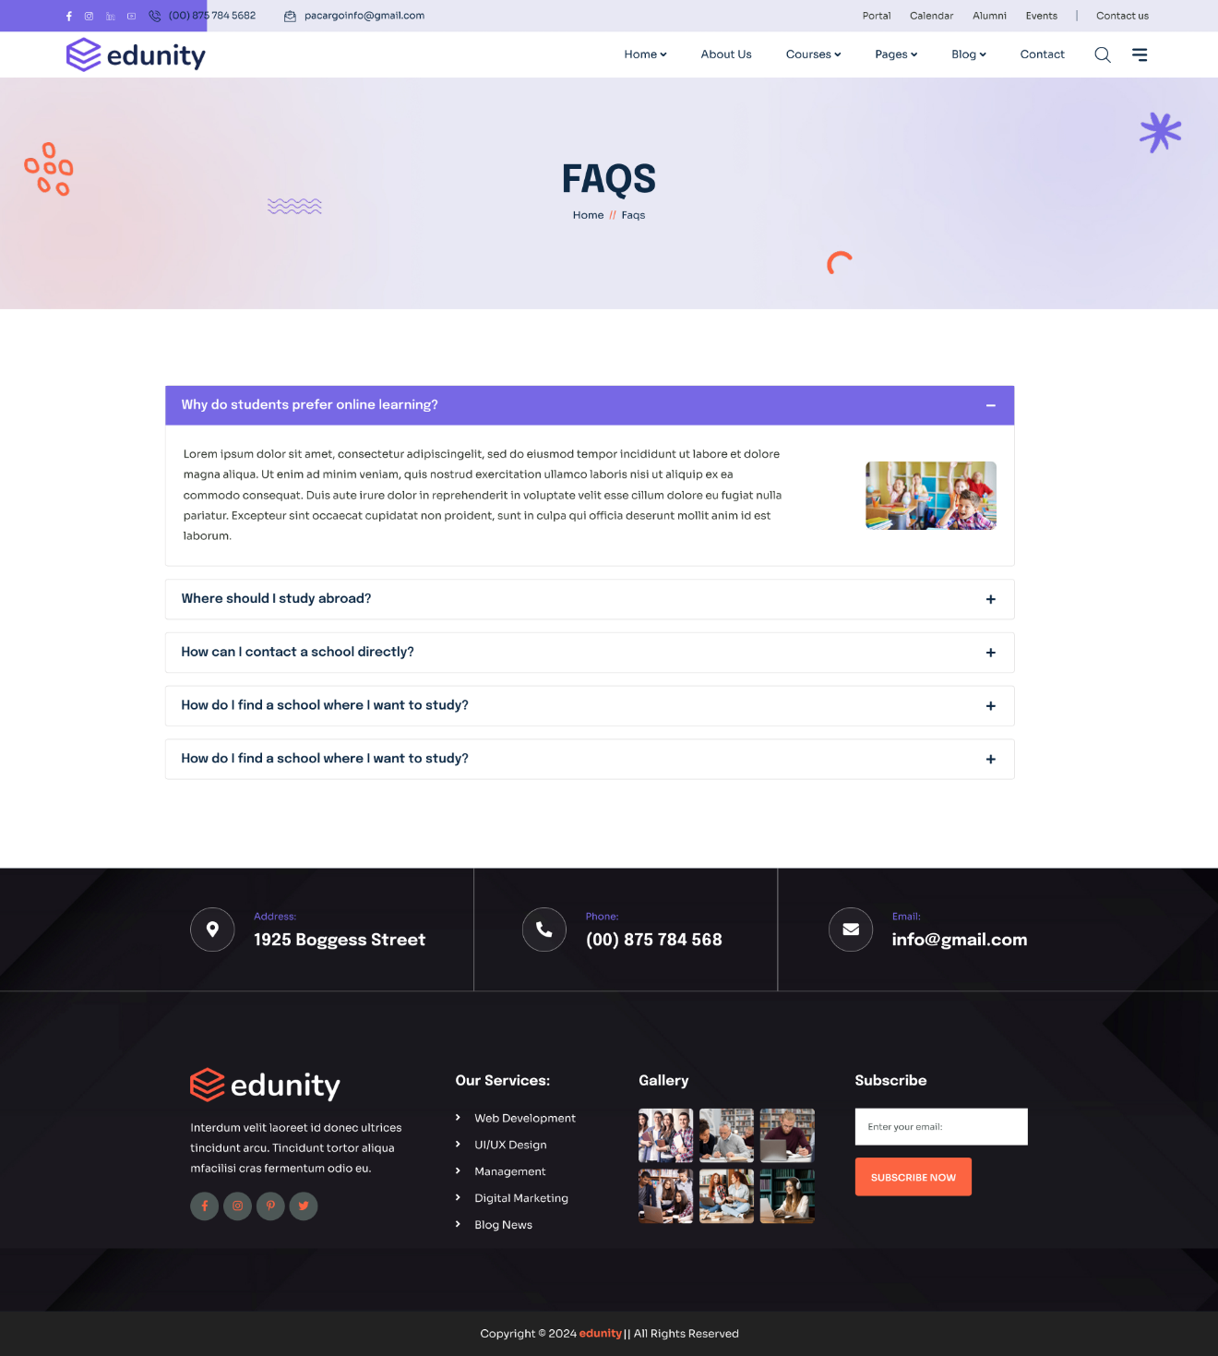
Figure 19: Prototype - PID14- FAQs Page

Project Planning and Execution using Sprints

Jira
Students would provide the link and credentials of their Jira project management credentials where they are managing their epics, stories and tasks

Slack
Students would provide the link and credentials of their slack communication management where they would be managing their project communication.

Github Repository
Students would provide the link and credentials of their Github repo where they would be maintaining their code Baselines.

Sprint 1
The goal of the first Sprint is to implement core functionalities including user authentication, dashboard, and profile management.

Sprint 1 Planning Meeting Minutes
Project Name: LIVEX UMT
Sprint Name: Sprint 1 – Initial Setup & Core Architecture
Sprint Duration: April 25, 2024 – May 25, 2024 (4 weeks)
Meeting Date: April 24, 2024
Facilitated by: FYP Supervisor. Product Owner
Attendees: Asif, Zainab, Ambreen, Suleiman

Backlog Items with high priority, high risk and Architecturaly Significant:
The following features are extracted from Product Backlog
Table 4: Selected Features of Product Backlog
PB-ID | User Story | Priority | Acceptance Criteria | Story Points | Status
AM-01 | As an instructor, I can create a description of a course so that prospective participants can learn about it. | High | - Instructor can add/edit a course description.  - Course description is saved and displayed correctly. | 3 | Pending
AM-02 | As an instructor, I can sign, login and maintain a bio about myself so that it is used on any course listing for which I’m the instructor. | Medium | - Instructor can add/update bio.  - Bio appears on all relevant course pages. | 2 | Pending
AM-03 | As a site visitor, I can view a detailed page about each course so that I can learn all about it. | High | - Course page displays course title, description, instructor bio, and related courses.  - Videos and syllabus are visible. | 3 | Pending
AM-04 | As a site visitor, I can browse a catalog of all courses available so that I can pick the right one for me. | High | - Course catalog lists all available courses.  - Filter and search functionality work correctly. | 5 | Pending
AM-05 | As a site visitor, I can see a list of other related courses when viewing a course so that I can see other courses I might be interested in. | Medium | - Related courses are displayed based on category, instructor, or tags. | 3 | Pending
AM-06 | As a student, I can Sign up, login into the system and see my registered courses (if any). | Medium | Courses are displayed | 3 | Pending

Team Capacity:
Following are the team members and their capacity

Table 5: Team Capacity Sprint 1
Member | Days Available | Hours/Day | Total Hours
Asif | 10 | 6 | 60
Zainab | 10 | 6 | 60
Ambreen | 9 | 5 | 45
Suleiman | 8 | 6 | 48

Action Items before Sprint Starts:
- Confirm GitHub repo setup – Zainab
- Share Figma design templates – Ambreen
- Create and Assign Jira tasks – Asif
- Share staging server credentials – Suleiman

Sprint 1 Backlog
The following tasks are extracted from Product Backlog features.

Table 6: Sprint 1 Backlog
SP-ID | Task Name | Related Product Backlog ID | Assigned To | Status | Estimated Effort (Hours) | Actual Effort (Hours) | Comments
S1-1 | Design login page | AM-01 | Asif | In Progress | 5 | 1 | Started it and UI mockup complete,
S1-2 | Implement login API | AM-01 | Zainab | In Progress | 8 | 3 | Testing API on Postman
S1-3 | Develop dashboard UI | AM-02 | Suleiman | In Progress | 10 | 4 | Working on React component
S1-4 | Integrate backend with dashboard | AM-02 | Ambreen | In Progress | 8 | 4 | Half work done
S1-5 | Develop profile update feature | AM-03 | Zainab | In Progress | 6 | 1 | Just started on profile update feature
S1-6 | Test profile management module | AM-03 | Zainab | Pending | 4 | 1 | Designing UI, rest depends on update profile
S1-7 | Create notification templates | AM-04 | Asif | In Progress | 5 | 3 | 7 out of 10 templates created
S1-8 | Develop notification service | AM-04 | Asif | Pending | 7 | 2 | Notification mechanism done but rest Depends upon profile management module
S1-9 | Implement file upload feature | AM-05 | Suleiman | Pending | 8 | 3 | Mechanism working but now working on making it secure
S1-10 | Test file upload functionality | AM-05 | Ambreen | Pending | 5 | 0 | Depends upon feature development completion
S1-11 | Set up development environment | N/A | Asif | Complete | 2 | 2 | Set up is done
S1-12 | Design DB schema for users/courses | AM-06, AM-01 | Zainab | In Progress | 8 | 4 | Almost half tables created
S1-13 | Create static landing page for login and sign up Figma to code Web | AM-06, AM-01 | Suleiman | In Progress | 4 | 3 | Page is almost done.
S1-14 | Draft course creation Figma to code UI | AM-01 | Ambreen | In Progress | 4 | 3 | Figma is almost completed
S1-15 | Setup Git repo and CI pipeline | AM-06 | Zainab | In Progress | 8 | 3 | Working on CI Pipeline is

Sprint 1 Design Class Diagram

You need to make a class diagram of the features selected from the product backlog and task division mentioned in Sprint Backlog. Following is the sample class diagram of few user stories that were covered in s single sprint. [4]

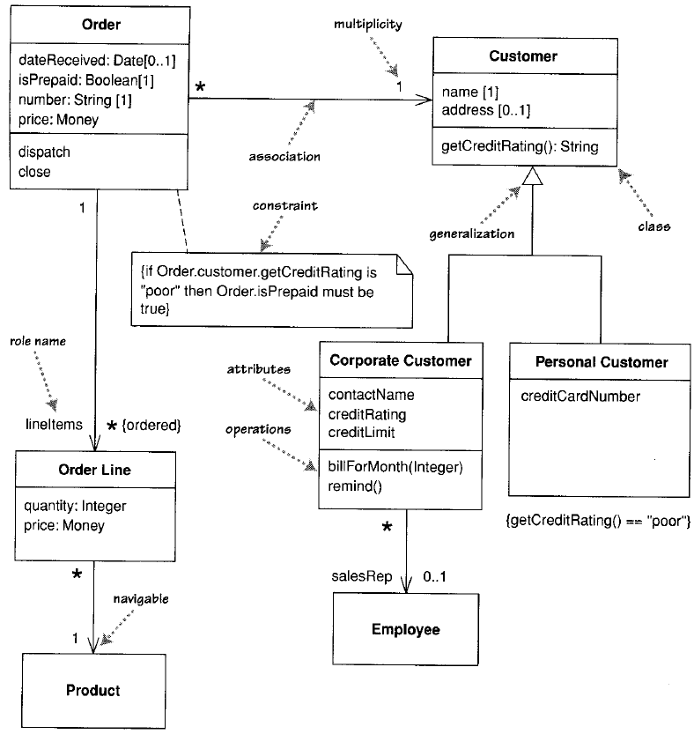
Figure 20: Class diagram of Sprint 1 features [4]

Sprint 1 Sequence Diagram

You need to give sequence diagrams of all the user stories involved in this sprint. Such as this following is is sample sequence diagram of Point of Sale system [2] user story of making Sales. Its partial diagram showing part of the functionality that is done in this sprint from process sale user story. Sample JAVA code is also given for your reference when we convert this design into code. You don’t need to give code here. Its mentioned here for your reference. [2]

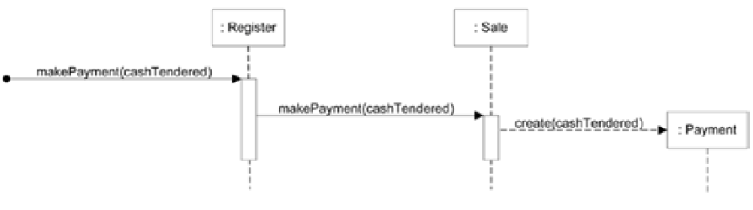
Figure 21: Sample Sprint 1 Sequence diagram POS 1 [2]

public class Sale
{
private Payment payment;
public void makePayment( Money cashTendered )
{
payment = new Payment( cashTendered );
//…
}
// …
}

The Order object asks each Order Line object to calculate its own Price. The Order Line object itself further hands off the calculation to the Product project; note how we show the passing of a parameter. Similarly, to calculate the discount, the Order object invokes a method on the Customer object. Because it needs information from the Order to do this, the Customer makes a reentrant call (getBaseVal ue) to the Order to get the data.
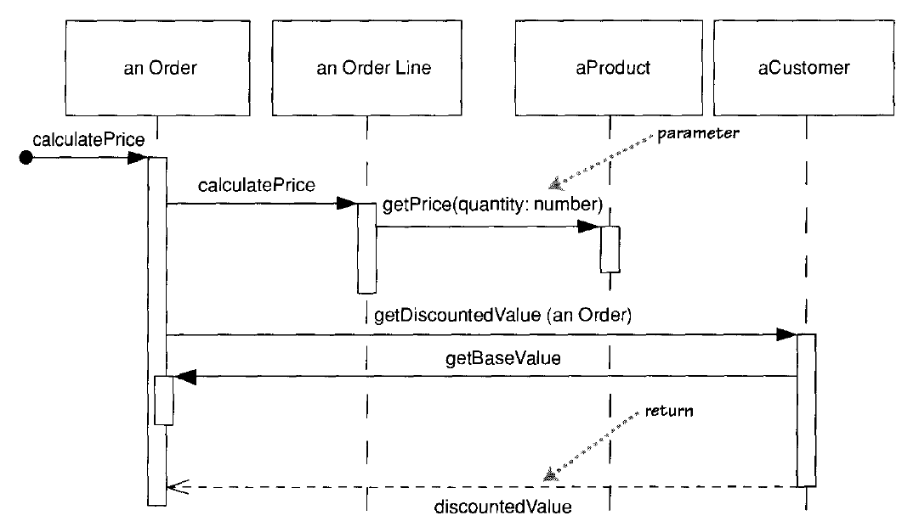
Figure 22: Sample Sprint 1 Sequence diagram POS [2]

Sprint 1 Decision Table
A software system is often governed by complex logic, with various combinations of conditions leading to different system behaviors. In such kind of user stories, it is advisable to create decision table in order to better understand possible combinations. Tesers are also advised to develop a separate test case for each possible combinations that check whether system is working fine in all those complex possible combinationss of input and outputs.
A sample Figure below shows a decision table for the logic that governs whether the Chemical Tracking System should accept or reject each request for a new chemical. Four factors influence this decision:
Whether the user who is creating the request is authorized to request chemicals
Whether the chemical is available either in the chemical stockroom or from a vendor
Whether the chemical is on the list of hazardous chemicals that require special training in safe handling
Whether the user who is creating the request has been trained in handling this type of hazardous chemical.
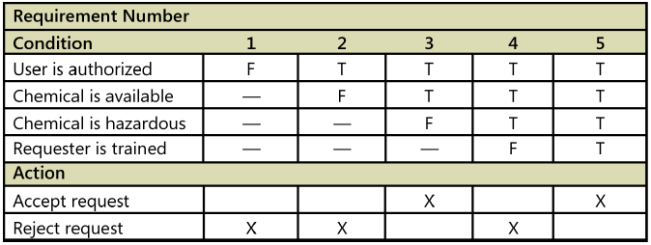
Figure 23: Sample Sprint 1 Decision Table Chemical Tracking System

Sprint 1 Extended Test Cases
Separate Test cases should be made against each user story to test the functionality.

Table 7: Sprint 1 Exteneded Test Case
Test Case ID: TID1 |  |  | Test Designed By: Ambreen
Epic Name and Backlog ID: Account Management AM-06 |  |  | Test Design Date: 17/05/2024
Test Priority: High |  |  | Test Executed by: - Zainab
Test Title: Verify Account Creation with Valid Data |  |  | Test Executed Date: -21/05/2024
Description: Make sure a student is easily able to register an account with correct details.

Selenium Web Driver Test created: Yes/No
Dependencies: None
Step | Test Step | Test Data | Expected Result | Actual Result | Status
1 | Select the option to register account. |  | The location of the registration form is shown next. | It should be noted that these fields shall be filled during testing. | Pass
2 | Enter valid data in the username field, i.e no space, tab, next line or special character allowed | Username: Muhammad Usman | The username is correct meaning that it is properly typed. | Same as the expected result
3 | Enter valid data in the Email field | Email: usman@gmail.com | The valid email address field is being filled appropriately. | Same as the expected result
4 | Enter valid data in the password field, Valid password must be at least 12 characters with at least one capital, one small letter, one number, one special character | Password: v$6xTOh1hEk& | The password is typed accurately. | Same as the expected result
5 | Click the “Register” button. |  | The registration information is accepted and processed by the system and a message is shown to the user. System displays the message that a link has been sent on the given email for verification. | System displays the message that a link has been sent on the given email for verification.
6 | Student checks inbox and click on the link provided to Activate the account. |  | The student is redirected to the login page with message shown that account has been activated successfully. | The student is redirected to the login page with message shown that account has been activated successfully.
Post Condition:
- A new account is created to be used by a new student.
- Using the registered e-mail address and password, the student can log in.

Sprint 1 Review Meeting

Sprint: Sprint 1 – Initial Setup & Core Architecture
Review Date: May 25, 2024
Duration: 1 hour
Facilitator: Product Owner / FYP Supervisor
Attendees: Asif, Zainab, Ambreen, Suleiman

The following table shows the status of tasks assigned to team members in the Sprint planning meeting.

Table 8: Status of Sprint 1 Backlog
ID | Task Name | Related Product Backlog ID | Owner | Status | Notes
S1-1 | Design login page | AM-01 | Asif | Completed | UI mockup complete,
S1-2 | Implement login API | AM-01 | Zainab | Completed | Tested API on Postman
S1-3 | Develop dashboard UI | AM-02 | Suleiman | Completed | React component completed
S1-4 | Integrate backend with dashboard | AM-02 | Ambreen | Completed | Integration done and tested
S1-5 | Develop profile update feature | AM-03 | Zainab | Completed | Profile update feature completed
S1-6 | Test profile management module | AM-03 | Zainab | Completed | Profile management completed
S1-7 | Create notification templates | AM-04 | Asif | Completed | All 10 templates created
S1-8 | Develop notification service | AM-04 | Asif | Completed | Notification mechanism done.
S1-9 | Implement file upload feature | AM-05 | Suleiman | Completed | Mechanism working and secure
S1-10 | Test file upload functionality | AM-05 | Ambreen | Completed | Tested and working fine.
S1-11 | Set up development environment | N/A | Asif | Completed | Environment set up is done and working fine.
S1-12 | Design DB schema for users/courses | AM-06, AM-01 | Zainab | Completed | DB created with all needed tables.
S1-13 | Create static landing page for login and sign up Figma to code Web | AM-06, AM-01 | Suleiman | Completed | Page created and delivered
S1-14 | Draft course creation Figma to code UI | AM-01 | Ambreen | Completed | Pages done and delivered
S1-15 | Setup Git repo and CI pipeline | AM-06 | Zainab | Completed | Repo is set up and working fine

Demo Highlights:
- User Authentication: Live demo by Asif showing signup/login flow with JWT.
- CI/CD: Zainab walks through the automated pipeline on GitHub.
- Landing Page: Ambreen shows the mobile-responsive homepage mockup.

Sprint Goal Achievement:
- All core objectives were completed on time, reviewed, and meet the definition of done.

Feedback from Stakeholders:

Feedback Source | Comments
Internal QA (Ambreen) | Registration form could use better validation
Product Owner (Team consensus) | DB schema is clean and extendable
Team Feedback | CI pipeline documentation was helpful

Metrics Overview:

Metric | Value
Committed Story Points | 21
Completed Story Points | 21
Carryover Items | 0
Bugs Reported / Resolved | 2 / 2

What Went Well:
- Team collaboration and communication
- Early setup of CI/CD saved time later
- Daily standups were effective and focused

What Could Be Improved:
- Need clearer guidelines for UI consistency
- More thorough test coverage for backend APIs

Action Items / Next Steps:

Action Item | Owner | Due Date
Implement frontend form validation | Ambreen | May 30, 2024
Add Swagger API docs to backend | Asif | May 30, 2024
Create new UI component styles | Zainab | May 30, 2024

Wrap-up
Team to move into Sprint 2 focused on Course Management features.
Next planning meeting scheduled for May 26, 2024.

Sprint 1 Retrospective Meeting

Sprint: Sprint 1 – Initial Setup & Core Architecture
Retrospective Date: May 25, 2024
Duration: 1 hour
Facilitator: Product Owner /FYP Supervisor
Attendees: Asif, Zainab, Ambreen, Suleiman

Sprint Overview
Goal: Establish the foundational architecture of the MOOC platform and implement user authentication module.
Sprint Duration: April 25, 2024 – May 25, 2024 (4 weeks)

What Went Well
- Successful implementation of authentication with JWT
- CI/CD pipeline setup early and was stable
- Team was responsive and collaborative during standups
- Clean database schema laid a strong foundation

What Didn’t Go Well

- UI validation rules were inconsistent across components
- Test coverage was minimal due to time constraints
- Ambiguity in acceptance criteria for some stories

Suggestions for Improvement

- Create a shared UI component style guide
- Include test case planning in story grooming sessions
- Improve story definitions and add clearer acceptance criteria
- Use pair programming for complex backend logic

Action Items:

Action Item | Owner | Due Date
Draft UI component style guide | Zainab | May 30, 2024
Add test planning checklist to grooming doc | Ambreen | May 30, 2024
Refine story templates with clearer definitions | Suleiman | May 30, 2024

Team Health Check:

- Team morale: Good
- Communication: Effective
- Tools and resources: Sufficient but can improve in UI design guidance

Wrap-up:
Team expressed overall satisfaction with the sprint outcomes and is aligned on areas of improvement. Looking forward to Sprint 2.

System Architecture
Describe the system architecture, or simply provide the architecture diagram according to C4 Model.

System context Diagram
A System Context diagram is a good starting point for diagramming and documenting a software system, allowing you to step back and see the big picture. Draw a diagram showing your system as a box in the centre, surrounded by its users and the other systems that it interacts with.
Detail isn’t important here as this is your zoomed out view showing a big picture of the system landscape. The focus should be on people (actors, roles, personas, etc) and software systems rather than technologies, protocols and other low-level details. It’s the sort of diagram that you could show to non-technical people.
See more details [5] at https://c4model.com/

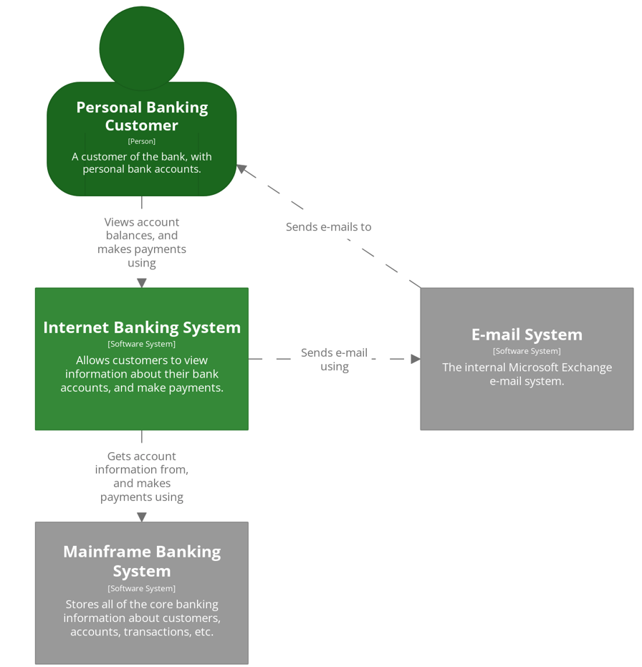
Figure 24: System context Diagram [5]

System Container Diagram

Once you understand how your system fits in to the overall IT environment, a really useful next step is to zoom-in to the system boundary with a Container diagram. A “container” is something like a server-side web application, single-page application, desktop application, mobile app, database schema, file system, etc. Essentially, a container is a separately runnable/deployable unit (e.g. a separate process space) that executes code or stores data.

The Container diagram shows the high-level shape of the software architecture and how responsibilities are distributed across it. It also shows the major technology choices and how the containers communicate with one another. It’s a simple, high-level technology focused diagram that is useful for software developers and support/operations staff alike.
See more details [5] at https://c4model.com/
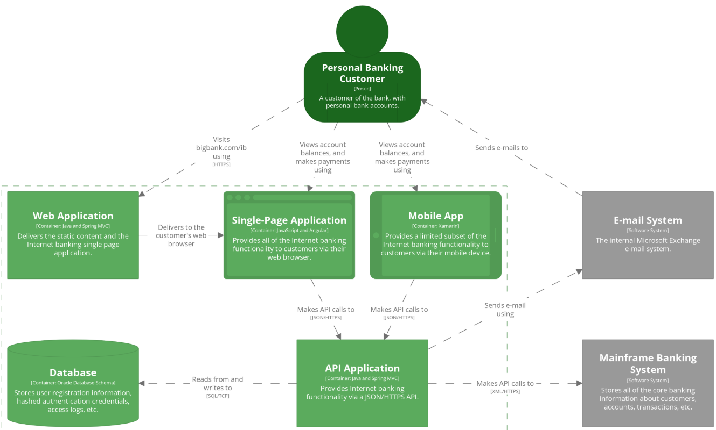
Figure 25: System container Diagram [5]

Component Diagram

Next you can zoom in and decompose each container further to identify the major structural building blocks and their interactions.
The Component diagram shows how a container is made up of a number of “components”, what each of those components are, their responsibilities and the technology/implementation details.
See more details [5] at https://c4model.com/

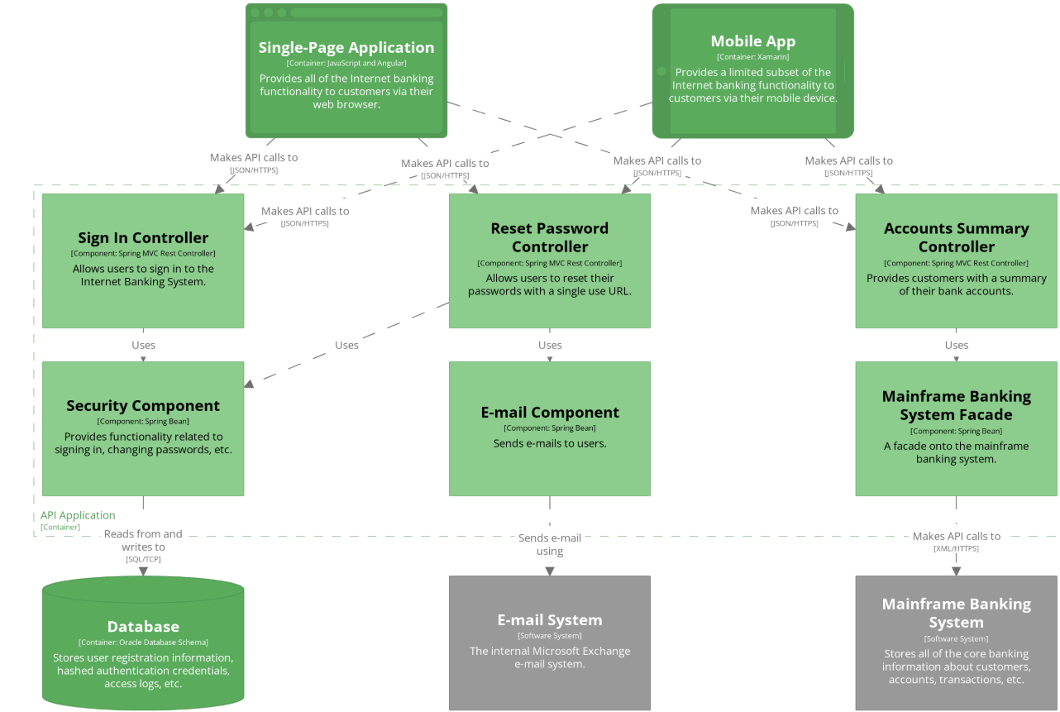

Figure 26: Component Diagram [5]

Code Diagrams
Finally, you can zoom in to each component to show how it is implemented as code; using UML class diagrams, entity relationship diagrams or similar.
This is an optional level of detail and is often available on-demand from tooling such as IDEs. Ideally this diagram would be automatically generated using tooling (e.g. an IDE or UML modelling tool), and you should consider showing only those attributes and methods that allow you to tell the story that you want to tell. This level of detail is not recommended for anything but the most important or complex components.
See more details [5] at https://c4model.com/

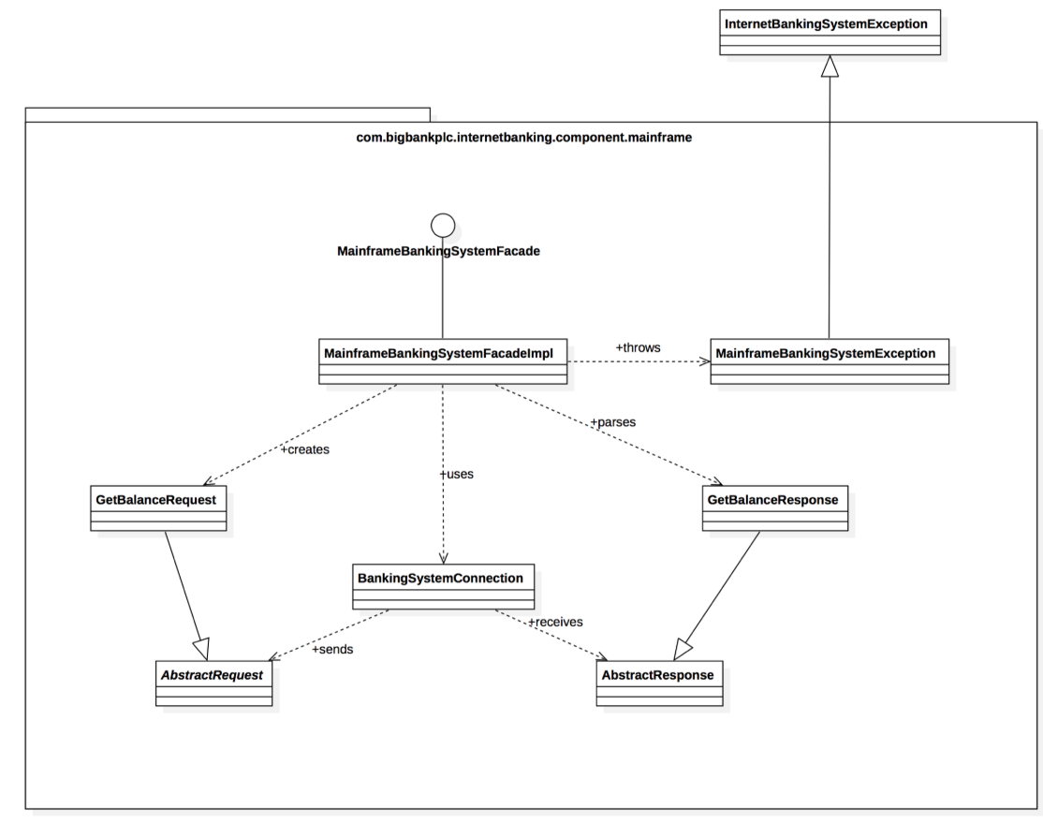
Figure 27: Component Diagram [5]

ERD
We now present another example, a UNIVERSITY database, [3] to illustrate the ER modeling concepts. Suppose that a database is needed to keep track of student enrollments in classes and students’ final grades. After analyzing the miniworld rules and the users’ needs, the requirements for this database were determined to be as follows (for brevity, we show the chosen entity type names and attribute names for the conceptual schema in parentheses as we describe the requirements; relationship type names are only shown in the ER schema diagram):
- The university is organized into colleges (COLLEGE), and each college has a unique name (CName), a main office (COffice) and phone (CPhone), and a particular faculty member who is dean of the college. Each college administers a number of academic departments (DEPT). Each department has a unique name (DName), a unique code number (DCode), a main office (DOffice) and phone (DPhone), and a particular faculty member who chairs the department. We keep track of the start date (CStartDate) when that faculty member began chairing the department.
- A department offers a number of courses (COURSE), each of which has a unique course name (CoName), a unique code number (CCode), a course level (Level: this can be coded as 1 for freshman level, 2 for sophomore, 3 for junior, 4 for senior, 5 for MS level, and 6 for PhD level), a course credit hours (Credits), and a course description (CDesc). The database also keeps track of instructors (INSTRUCTOR); and each instructor has a unique identifier (Id), name (IName), office (IOffice), phone (IPhone), and rank (Rank);
in addition, each instructor works for one primary academic department.
- The database will keep student data (STUDENT) and stores each student’s name (SName, composed of first name (FName), middle name (MName), last name (LName)), student id (Sid, unique for every student), address (Addr), phone (Phone), major code (Major), and date of birth (DoB). A student is assigned to one primary academic department. It is required to keep track of the student’s grades in each section the student has completed.
- Courses are offered as sections (SECTION). Each section is related to a single course and a single instructor and has a unique section identifier (SecId). A section also has a section number (SecNo: this is coded as 1, 2, 3, . . . for multiple sections offered during the same semester/year), semester (Sem), year (Year), classroom (CRoom: this is coded as a combination of building code (Bldg) and room number (RoomNo) within the building), and days/times (DaysTime: for example, ‘MWF 9am-9.50am’ or ‘TR 3.30pm-5.20pm’— restricted to only allowed days/time values). (Note: The database will keep track of all the sections offered for the past several years, in addition to the current offerings. The SecId is unique for all sections, not just the sections for a particular semester.) The database keeps track of the students in each section, and the grade is recorded when available (this is a many-to-many relationship between students and sections). A section must have at least five students.
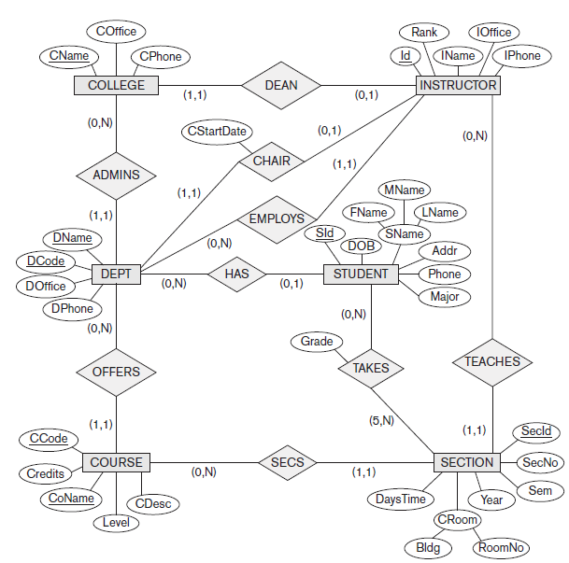
Figure 28: ER Diagram for University Scenario [3]
The ER diagram for these requirements is shown in Figure 28 using the min-max ER diagrammatic notation. Notice that for the SECTION entity type, we only showed SecID as an underlined key, but because of the miniworld constraints, several other combinations of values have to be unique for each section entity. For example, each of the following combinations must be unique based on the typical miniworld constraints:
- (SecNo, Sem, Year, CCode (of the COURSE related to the SECTION)): This specifies that the section numbers of a particular course must be different during each particular semester and year.
- (Sem, Year, CRoom, DaysTime): This specifies that in a particular semester and year, a classroom cannot be used by two different sections at the same days/time.
- (Sem, Year, DaysTime, Id (of the INSTRUCTOR teaching the SECTION)): This specifies that in a particular semester and year, an instructor cannot teach two sections at the same days/time. Note that this rule will not apply if an instructor is allowed to teach two combined sections together in the particular university

Data Dictionary
A data dictionary [1] is a collection of detailed information about the data entities used in an application. Collecting the information about composition, data types, allowed values, and the like into a shared resource identifies the data validation criteria, helps developers write programs correctly, and minimizes integration problems. The data dictionary complements the project glossary, which defines application domain or business terms, abbreviations, and acronyms. We recommend keeping the data dictionary and the glossary separate. This information feeds into design in the form of database schemas, tables, and attributes, which ultimately lead to variable names in programs. The time you invest in creating a data dictionary will be more than repaid by avoiding the mistakes that can result when project participants have different understandings of the data.
Following is the sample data dictionary of chemical tracking system.[1]

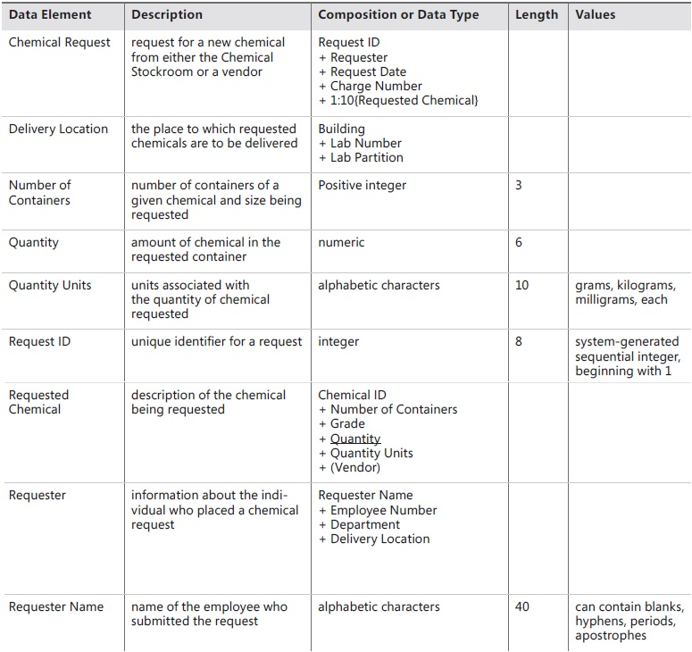
Figure 29: Data Dictionary of Chemical Tracking System [1]

Implementation details

Development Setup
List your tools and technologies and their role in development.

Deployment setup
How and where was your software deployed? Did you face any problems, how did you overcome these problems.

Algorithms
Entire code of software is not required. Just highlight your important (user defined/ improved) algorithms.

Constraints

Assumptions
Things we assume will be true.
e.g.:
- We will receive all necessary technical support from the engineers at cMeRun, Select and Mellon Bank to help design the interfaces between their systems and enGyro.
- All database maintenance will be handled by the client.
- There will be no real-time interfacing with any accounting systems.

System constraints
A constraint specifies how the system must operate or how it must be built

Restrictions
Constraints applied on the system by the client

Limitations
Services your software is unable to provide

Project Monitoring, control and traceability

Traceability Matrix

Requirements vs Prototype (PB-ID vs PID)
PB-ID vs  PID | PID1 | PID2 | PID3 | PID4 | PID5 | PID6 | PID7 | PID8 | PID9 | PID10 | PID11 | PID12 | PID13 | PID14 | PID15 | PID16 | PID17 | PID18 | PID19 | PID20
CC01
CC02
CC03
CC04
CC05
CC06
CC07
CC08
CC09
BC-01
BC-02
BC-03
BC-04
BC-05
BC-06
BC-07
BC-08
BC-09
BC-10
LA-01
LA-02

Requirements vs Test Cases (PB-ID vs TID)

PB-ID vs  TID | TID1 | TID2 | TID3 | TID4 | TID5 | TID6 | TID7 | TID8 | TID9 | TID10 | TID11 | TID12 | TID13 | TID14 | TID15 | TID16 | TID17 | TID18 | TID19 | TID20
CC01
CC02
CC03
CC04
CC05
CC06
CC07
CC08
CC09
BC-01
BC-02
BC-03
BC-04
BC-05
BC-06
BC-07
BC-08
BC-09
BC-10
LA-01
LA-02

Results/Output/Statistics

%completion
Use the matrix & values from 7.3.1 to show that all requirements are being fulfilled.

%accuracy
Use the matrix & values from 7.3.3 to show that all requirements have been implemented correctly.

%correctness
Use the matrix & values from 7.3.4 to show that all requirements have been tested to be conforming to requirements.

Conclusion

Future work

Bibliography
Use IEEE or ACM format for citations

Books
- Karl E Wiegers and Joy Beatty. 2013. Software Requirements 3. Microsoft Press, USA.
- Craig Larman. 2001. Applying UML and Patterns: An Introduction to Object-Oriented Analysis and Design and the Unified Process (2nd. ed.). Prentice Hall PTR, USA.
- Ramez Elmasri and Shamkant B. Navathe. 2015. Fundamentals of Database Systems (7th. ed.). Pearson.
- Martin Fowler. 2003. UML Distilled: A Brief Guide to the Standard Object Modeling Language (3rd. ed.). Addison-Wesley Longman Publishing Co., Inc., USA.

Journals

Articles

Research papers

Other References
5 https://c4model.com/

Appendix

Glossary of terms

Pre-requisites
Must use contents of development/ deployment setup & external system dependencies

